**WINTER STUDENT ENRICHMENT PACKET**

**Kindergarten**

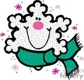

**Elementary Reading/English Language Arts and Social Studies**

**™**

**Prince George’s County Public Schools**

**Office of Academic Programs**

**Department of Curriculum and Instruction**

**Kindergarten Student Enrichment Packet**

**Note to Students:**

You’ve learned a great deal already this school year! It is important that you keep your brain active over the Winter Break. In this packet, you will find activities to last until you return to school. When you’re not sledding, or drinking hot chocolate, complete this packet so you will get off to a good start in the New Year!

DIRECTIONS

*There are six different activities in this booklet: Poetry, Newspaper, Name that Sound, Let Us Write This Way, Climate, and Television.* ***Choose three (3) different activities to complete in this booklet.***

**Parents are encouraged to assist in the following ways:**

* Provide your child with the necessary supplies such as a pencil, crayons, scissors, glue, etc.
* Make a plan to complete the activities during the Winter Break.
* Provide a quiet space and time for your child to work on the packet.
* Help your child with the directions. Your child should be able to do most of the activities with minimal supervision.
* Review and discuss your child’s responses. Provide positive feedback and praise for sincere effort and independence.
* If your child is just beginning to learn to write independently, encourage him/her to write and spell as best as he or she can. You may rewrite the sentence underneath the child’s to show correct letter formation and spelling.
* Encourage daily reading of 20-30 minutes of a self-selected book. Read to your child, listen to him/her read, or share the reading. Record the books read on the independent reading log attached at the end of the packet.

**Thank you for helping your child succeed!**

**POETRY ACTIVITIES**

***Directions:*** Use the poem for the following activities.

* Read the poem aloud. Have the whole family learn it with you. Recite it as often as you can. Read and/or recite the poem to someone else in your family.
* Illustrate the poem (use the sheet provided). Be sure to include details in the poem.
* Highlight or circle the letters you find in the poem that are in your name.
* Highlight or circle the words you know in the poem. Using the words you highlighted or circled, write a sentence for each of them (use the sheet provided).

**Snowman**

I made him big and round,

I made him from a snowball,

I rolled upon the ground.

He has two eyes, a nose, a mouth,

A lovely scarf of red

He even has some buttons,

And a hat upon his head,

Melt, melt, melt, melt

Melt, melt, melt, melt.

From: Sing a Song of Poetry By: Gay Su Pinnell and Irene C. Fountas

Poetry Activities: Snowman

|  |  |
| --- | --- |
| Words I Know From the Poem | I Can Write Sentences Too! |
|  |  |
|  |  |
|  |  |
|  |  |
|  |  |

My illustration of the poem

|  |
| --- |
|  |

**NEWSPAPER ACTIVITY**

***Directions:*** On the sheet provided, write the letters of your first and/or last name in the first column. Next to each letter, write or cut out at least two words you can find in the newspaper that start with that letter. Be sure that you can read the words you write down.

|  |  |  |
| --- | --- | --- |
| **Letters of Your Name**  ⮋ |  | |
|  | 1. | 2. |
|  | 1. | 2. |
|  | 1. | 2. |
|  | 1. | 2. |
|  | 1. | 2. |
|  | 1. | 2. |
|  | 1. | 2. |
|  | 1. | 2. |
|  | 1. | 2. |
|  | 1. | 2. |
|  | 1. | 2. |
|  | 1. | 2. |
|  | 1. | 2. |
|  | 1. | 2. |
|  | 1. | 2. |

**NAME THAT SOUND ACTIVITY**

***Directions****:* Write the letter that corresponds to the beginning sound for each picture on the lines below. *Challenge*: Write the name of each object on the line.







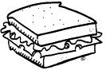

_____________ _____________ _____________ _____________

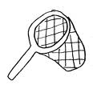

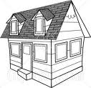

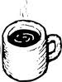

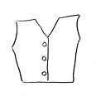

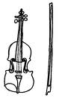

_____________ _____________ _____________ _____________

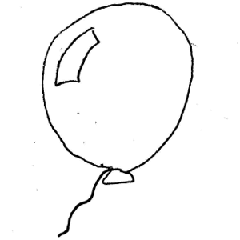

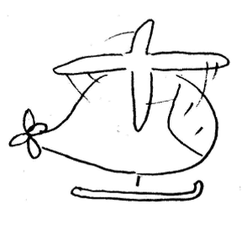

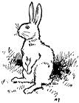

_____________ _____________ _____________ _____________

**LET US WRITE THIS WAY**

***Direction:*** Practice writing the letters two times.

S

_________________________________________________________________________

s

_ _ _ _ _ _ _ _ _ _ _ _ _ _ _ _ _ _ _ _ _ _ _ _ _ _ _ _ _ _ _ _ _ _ _ _ _ _ _ _ _ _ _ _ _ _ _ _ _

_________________________________________________________________________

_________________________________________________________________________

m

M

_ _ _ _ _ _ _ _ _ _ _ _ _ _ _ _ _ _ _ _ _ _ _ _ _ _ _ _ _ _ _ _ _ _ _ _ _ _ _ _ _ _ _ _ _ _ _ _ _

_________________________________________________________________________

_________________________________________________________________________

v

V

_ _ _ _ _ _ _ _ _ _ _ _ _ _ _ _ _ _ _ _ _ _ _ _ _ _ _ _ _ _ _ _ _ _ _ _ _ _ _ _ _ _ _ _ _ _ _ _ _

_________________________________________________________________________

B

_________________________________________________________________________

b

_ _ _ _ _ _ _ _ _ _ _ _ _ _ _ _ _ _ _ _ _ _ _ _ _ _ _ _ _ _ _ _ _ _ _ _ _ _ _ _ _ _ _ _ _ _ _ _

_________________________________________________________________________

N

_________________________________________________________________________

n

_ _ _ _ _ _ _ _ _ _ _ _ _ _ _ _ _ _ _ _ _ _ _ _ _ _ _ _ _ _ _ _ _ _ _ _ _ _ _ _ _ _ _ _ _ _ _ _ _

_________________________________________________________________________

T

_________________________________________________________________________

_ _ _ _ _ _ _ _ _ _ _ _ _ _ _ _ _ _ _ _ _ _ _ _ _ _ _ _ _ _ _ _ _ _ _ _ _ _ _ _ _ _ _ _ _ _ _ _ _

_________________________________________________________________________

H

_________________________________________________________________________

h

_ _ _ _ _ _ _ _ _ _ _ _ _ _ _ _ _ _ _ _ _ _ _ _ _ _ _ _ _ _ _ _ _ _ _ _ _ _ _ _ _ _ _ _ _ _ _ _ _

_________________________________________________________________________

**CLIMATE ACTIVITIES**

***Directions:***

1. Color the pictures. Then cut and paste the pictures to the correct season.

|  |  |
| --- | --- |
| MM900283455[1] | MC900059745[1] |
| MC900331475[1] | MC900089556[1] |
| MC900215699[1] | MC900232131[1] |
| MC900446114[1] | MC900030623[1] |

**Winter**

MC900446356[1]

**Summer**

MC900090084[1]

**TELEVISION ACTIVITIES**

***Directions:***

1. Identify the different part of the story you are watching: setting, main characters, problem, and solution.
2. Illustrate the setting and main characters on the sheet provided. Write a sentence on how a character in the show made you feel.
3. Write a sentence about your favorite part.
4. Illustrate and/or write about the problem and how it was solved in the show.

|  |  |
| --- | --- |
| **Setting** | **Main Characters** |
|  |  |
| “ _______________ made me feel ________________ because  ____________________________________________________.” | |

|  |  |
| --- | --- |
| **Problem** | **Solution(s)** |
|  |  |

|  |
| --- |
| My favorite part of the show is  _________________________________________________________________________  _________________________________________________________________________  _________________________________________________________________________  _________________________________________________________________________  ________________________________________________________________________. |

**READING LOG**

|  |  |  |
| --- | --- | --- |
| **Name of Book** | **Author** | **Book Review**  **Did you like this book?** |
|  |  | ☺ 😐 ☹ |
|  |  | ☺ 😐 ☹ |
|  |  | ☺ 😐 ☹ |
|  |  | ☺ 😐 ☹ |
|  |  | ☺ 😐 ☹ |
|  |  | ☺ 😐 ☹ |
|  |  | ☺ 😐 ☹ |
|  |  | ☺ 😐 ☹ |
|  |  | ☺ 😐 ☹ |
|  |  | ☺ 😐 ☹ |
|  |  | ☺ 😐 ☹ |
|  |  | ☺ 😐 ☹ |