**Foundations for Algebra**

**Winter Student Enrichment Packet**



PRINCE GEORGE’S COUNTY PUBLIC SCHOOLS

Office of Academic Programs

Department of Curriculum and Instruction

**™**

***NOTE TO THE STUDENT***

*This Winter Student Enrichment Packet has been compiled to complement middle school mathematics classroom instruction aligned to the Maryland College and Career Ready Standards (MCCRS). The packet is intended to be used for* ***review and practice*** *of previously taught and new concepts.*

*We strongly encourage you to work diligently to complete the activities for the choice board. You may experience some difficulty with some activities in this packet, but we encourage you to think critically and creatively and complete them to the best of your ability.*



**Foundations for Algebra Winter Enrichment Choice Board: Three-Course Meal**

Complete the specified number of appetizers, main dishes, and desserts as indicated below.

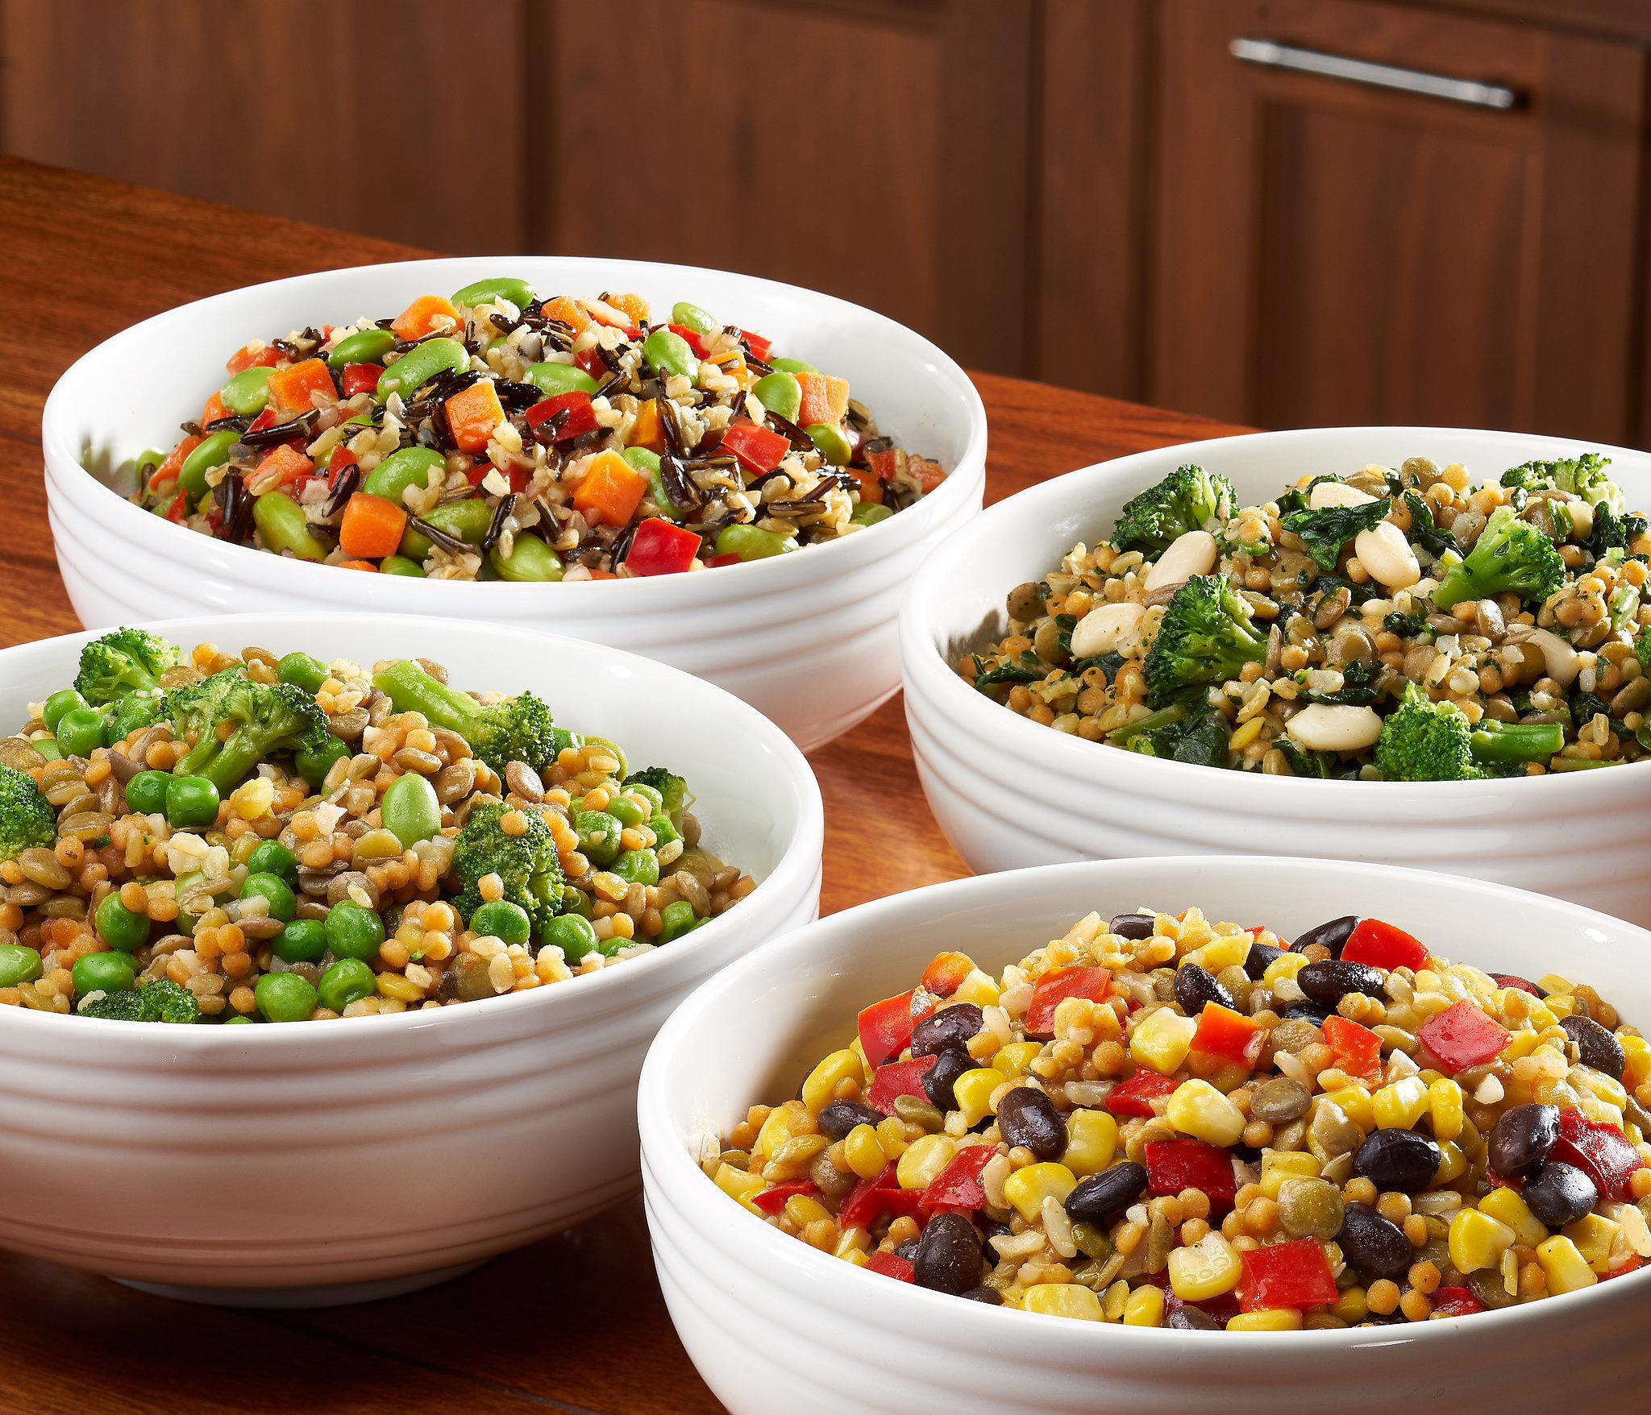

**Appetizers (Select 2)**

1

Identify if the given function is linear or nonlinear.

2

Classify the solutions to linear equations as having *one solution*, *no solution*, or *infinitely many solutions*.

3

Solve each inequality and graph its solution.

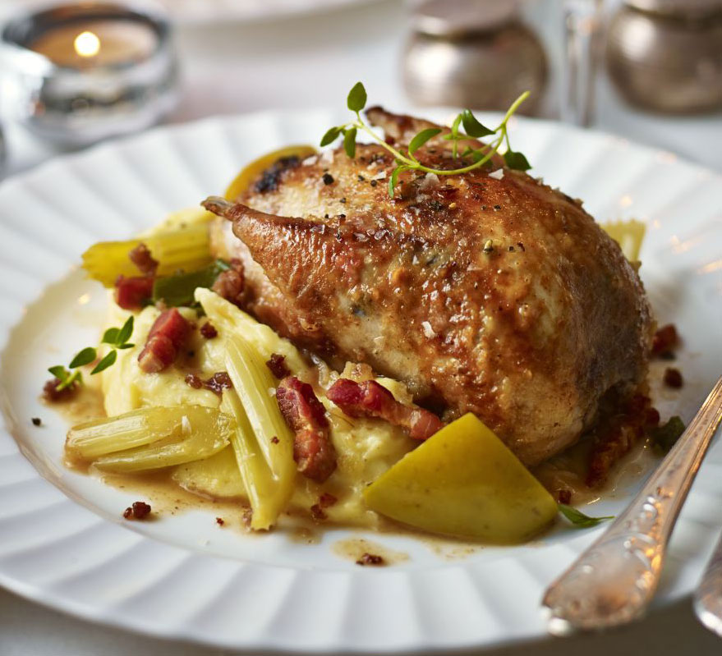



**Main Dishes (Complete All)**

3

2

1

Write equations in slope-intercept form given graphs of the lines on the coordinate grid.

Equations and functions mixed practice.

Write a system of equations to match a real-world situation.



**Desserts (Select 1)**

1

Puzzle Time: Solve the solution of the systems of equations using multiplication with the addition method (equations are not necessarily in standard form).

2

Crossword Puzzle: Solve the puzzle in relation to linear functions.

**Appetizer 1: Identifying Linear or Nonlinear Functions**

**Directions:** Identify if the function is linear or nonlinear. Write the **letter** of your answer in the appropriate box below.

**Nonlinear**

**Linear**

**N**. The graph shows a function. **R**. The graph shows a function. Is the function

Is the function linear or nonlinear? linear or nonlinear?

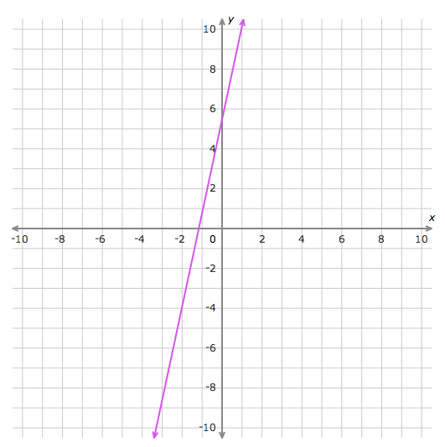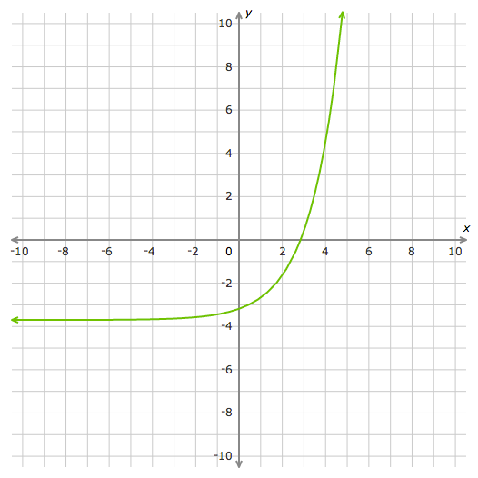

**O**. Is the function *y* = 3*x* + 2 **Y**. Is the function  *y* = –8 linear or nonlinear?

linear or nonlinear?

**B**. Is the function $y=\frac{1}{9x}-6$**E**. The table shows a function.

linear or nonlinear? Is the function linear or nonlinear?

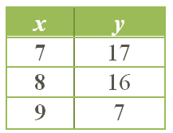

**R**. The table shows a function.

Is the function linear or nonlinear?

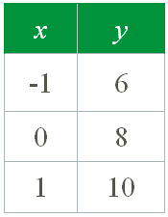

**T**. The graph shows a function. Is the

function linear or nonlinear?

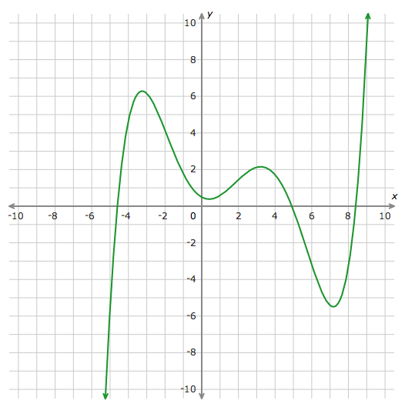

**D**. Is the function $y=\frac{2}{3}+\frac{3}{8}\sqrt{x}$

linear or nonlinear?

**Appetizer 2: Classifying Solutions to Linear Equations**

**Directions:**

1. Put a **check** (√) mark on the blank before the item number if the equation has **one solution**.

2. Put an ***×***  mark on the blank before the item number if the equation has **no solution**.

3. Put a **pound** (#) mark on the blank before the item number if the equation has **infinitely many solutions**.

|  |  |
| --- | --- |
| ______ 1. 6x – 3 = 5x + 5 | ______ 2. 8x – 3 = 8x + 5 |
| ______ 3. 3x – 3 = –3 + 3x | ______ 4. 11x – 2x + 15 = 8 + 7 + 9x |
| ______ 5. 3(x – 14) + 1 = –4x + 5 | _______ 6. –3x +32 – 7x = –2(5x + 10) |
| ______ 7. (8x + 26) = 13 + 4x | ______ 8. 18x +  = 6(3x + 25) |
| ______ 9. 8 – 9x = 15x + 7 + 3x | _____ 10. 5(x + 9) = 5x + 45 |
| _____ 11. 6x + 1 = 1 + 6x | _____ 12. –2x – 4 = –2x + 4 |

**Appetizer 3: Solving Inequalities and Graphing Solutions**

**Directions:** Solve each inequality and graph its solution. Show your work.

Graph of solution

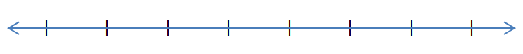1. 18 ≥ ** + 8 1.



2. *x* – 2*x* + 3 > 6 2.



3. –4 + 3*x*  –8 3.



4. –4*x* – 6 –18 4.



5. 28 3 – 5*x* 5.

6. *x* + 7 –3 6.

**Main Dish 1: Writing Equations in Slope-Intercept Form**

**Directions:** Write the equation of the line shown in each graph in slope-intercept form. Note that each grid line is equivalent to 1 unit. Write each answer in the blank.

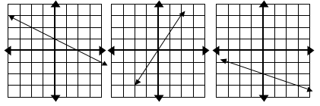**1. ______________________________ 2. __________________________ 3. _____________________________**

4. ______________________________ 5. __________________________ 6. ____________________________

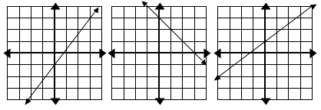

**Main Dish 2: Equations and Functions Mixed Practice**

**Multiple Choice:** Circle the correct answer or answers for each problem.

|  |
| --- |
| 1. Which of the following could **NOT** be the graph of a function? Select all that apply.  a.  b. Description: Macintosh HD:Users:norberto.torbeso:Desktop:graph.tiff c.  d. |
| 2. Worried about going over his storage limit, Kenneth monitored the number of undeleted voicemail messages stored on his phone each day.  According to the graph, what was the rate of change between Thursday and Friday?   1. –3 voicemail messages per day 2. –2 voicemail messages per day 3. 3 voicemail messages per day 4. 2 voicemail messages per day |
| Description: Macintosh HD:Users:norberto.torbeso:Desktop:Graph3.tiff3. This graph shows how the total number of stamps Maria has in her collection is related to the amount of money she spends on additional stamps.  With $60 to spend on new stamps, how many total stamps can Maria have in her collection?  a. 60 stamps b. 20 stamps  c. 80 stamps d. 50 stamps |
| 4. Cristelle started making this table of values to show the relationship between the number of scarves she sells, *x*, and the profit, *y*, in dollars, she earns in her business.   |  |  |  |  |  |  | | --- | --- | --- | --- | --- | --- | | *x* | 1 | 2 | 3 | 4 | 5 | | *y* | ? | –110 | –90 | –70 | –50 |   What is the missing value in this table?  a. –100 b. –120 c. –130 d. –150 |

|  |
| --- |
| 5. Stacey entered the amount she charged on her credit card each month into a spreadsheet.    According to the table, what was the rate of change between April and May?  a. –$8 per month b. $8 per month  c. $150 per month d. –$150 per month |
| 6. How is the equation *y* = -4*x* + 1 written in function notation?    a. f(*x*) = –4*f* + 1 b. f(*x*) = –4*x* + 1  c. f(*x*) = –4y + 1 d. f(x) = –4f(*x*) + 1 |
| 7. Sophia walks at a speed of 2.5 miles per hour. Which equation models this unit rate?    a. *x* = 2.5*y* b. *x* = 2.5 + *y*  c. *y* = 2.5*x* d. *y* = 2.5 + *x* |
| 8. Which number line below correctly shows  the solution set for the inequality  ?    a. b.      c. d. |

|  |  |
| --- | --- |
| 9. Triangle MNP is similar to triangle QRS.  Description: Macintosh HD:Users:norberto.torbeso:Desktop:graph.tiff    Which sides have the same slope?  a. $\overline{MP }$ and $\overline{QS}$ b. $\overline{MP }$ and $\overline{NP}$ c. $\overline{QR }$ and $\overline{QS}$ d. $\overline{QR }$ and $\overline{NP}$ | 10. What is the solution to the system of  Description: Macintosh HD:Users:norberto.torbeso:Desktop:graph.tiff equations shown on this graph?        a. (1, 4) b. (–1, 4)  c. (4, 1) d. (4, –1) |
| 11. Inspect the system of equations shown below. $$\left\{\begin{aligned}x+3y=1 \\ 2x+6y=2\end{aligned}\right.$$   How many solutions does this system of linear equations have?  a. 0 b. exactly 2  c. exactly 1 d. infinitely many | 12. Stacey wants to graph this system of equations: $$\left\{\begin{aligned}3x-y= 4 \\ 2x+3y=-6\end{aligned}\right.$$ Which choice below shows how she should rewrite these equations in slope-intercept form?  a. $\left\{\begin{aligned}y=3x + 4 \\ y=-\frac{2}{3}x-2\end{aligned}\right.$ b. $\left\{\begin{aligned}y=3x - 4 \\ y=-\frac{3}{2}x-3\end{aligned}\right.$ c. $\left\{\begin{aligned}y=3x - 4 \\ y=-\frac{2}{3}x-2\end{aligned}\right.$ d. $\left\{\begin{aligned}y=3x + 4 \\ y=-\frac{3}{2}x-3\end{aligned}\right.$ |

**Main Dish 3: Writing Systems of Equations**

Systems of equations can be used to represent many real-world situations. An example of systems of equations applied in a **Uniform Motion Problem** is shown below.

|  |
| --- |
| **Problem:** Flying with the wind, a plane can fly 750 miles in 3 hours. Against the wind, the plane can fly the same distance in 5 hours. Write a system of equations to represent the situation. |
| **Strategy** 1. Choose one variable to represent the plane in a calm condition and a second variable to represent the rate of the wind or current.  let *p* = the rate of the plane in calm air  *w* = rate of the wind  so that *p* + *w* = rate of the plane traveling with the wind  *p* - *w* = rate of the plane traveling against the wind  2. Use the expressions from step 1, as well as the time traveled with and against the wind, to get expressions for the distances traveled with and against the wind. Recall:  is used to determine the expression for the distance traveled. Organize the data in a table.   |  |  |  |  |  |  | | --- | --- | --- | --- | --- | --- | | **Trip** | **Rate** |  | **Time** | **=** | Distance | | With the wind |  |  |  | = |  | | Against the wind |  |  |  | = |  |   3. Write a system of equations that models the problem.   |  |  |  |  |  |  | | --- | --- | --- | --- | --- | --- | | **Trip** | **Rate** |  | **Time** | **=** | Distance | | With the wind | (p + w) |  | 3 | = | 750 | | Against the wind | (p – w) |  | 5 | = | 750 |   So, the system of equations would be: $\left\{\begin{aligned}3\left(p+w\right)=750 \\ 5\left(p-w\right)=750\end{aligned}\right.$ |

**Writing Systems of Equations Activity**

**Directions:** Write a system of equations to represent each situation that could be used to determine the answer to the question in the problem. *Do not find the solution to the system.*

|  |  |
| --- | --- |
| 1. Flying with the wind, an airplane made a 708-mile trip in 3 hours. Flying against the wind to make the same trip, the plane took 4 hours. What is the speed of the wind and how fast would the plane travel in still air? | 1. A field goal is 3 points and the extra point after a touchdown is 1 point. To begin the season, a kicker successfully made a total of 30 kicks for a total of 56 points. How many field goals and how many extra points did the kicker make? |
| 1. A restaurant has one price for adults and another price for children to eat at its buffet. Two families ate at the buffet. The Traymore family has two adults and three children and their bill was $49.50. The Willis family has three adults and one child and their bill was $44.50. What is the cost for an adult to eat at the buffet and what is the cost of a child to eat at the buffet? | 1. A student is selling pizzas for $6 and sub sandwiches for $4 for a fundraiser. The student sold 13 more sub sandwiches than pizzas and collected a total of $262. How many pizzas and how many sub sandwiches did the student sell? |
| 1. The library is having a book sale. Hardcover books are selling for $5 each and paperback books are selling for $3 each. Mrs. Smith spent $51 to buy 13 books. How many of each type of book did Mrs. Smith purchase? | 1. At a store, all shirts are priced the same and all jeans are priced the same. Amy bought four shirts and three pairs of jeans for $150. Brianna bought one shirt and two pairs of jeans for $70. What is the cost of a shirt at the store? What is the cost for a pair of jeans at the store? |

**Dessert**

**Puzzle Time (**Adapted from Algebra with Pizzazz!**)**

**1**

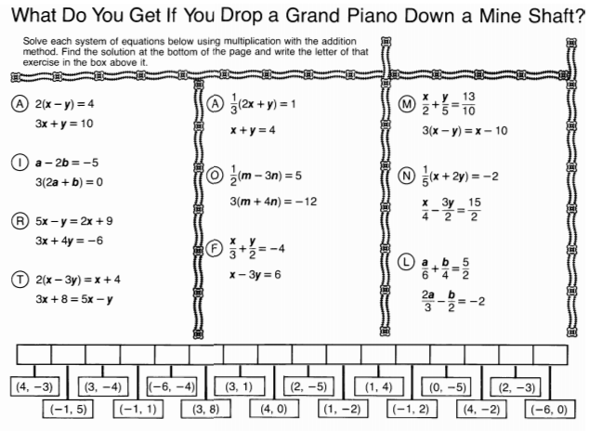

**Dessert 2** Linear Functions Crossword Puzzle

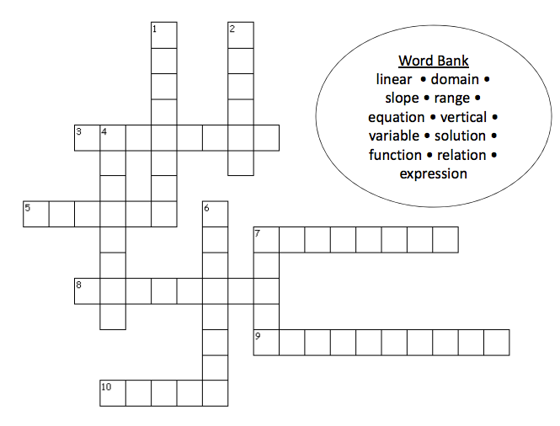

**Across:**

3. The __________ line test that allows you to discover visually whether a relation is a function.

5. The first coordinates in a set of ordered pairs.

7. A set of ordered pairs.

8. An ordered pair that makes an equation with two variables true.

9. A mathematical phrase that uses variables, numbers, and operations.

10.  The ratio of rise over run.

**Down:**

1.  A relationship in which each member of the domain is paired with exactly one member of the range.

2.  A(n) ________________ equation is an equation whose graph is a line.

4.  A mathematical sentence with an equal sign.

6.  A letter stands for a number.

7.  The second coordinates in a set of ordered pairs.