Math 7
Winter Student
Enrichment Packet
ANSWER KEY

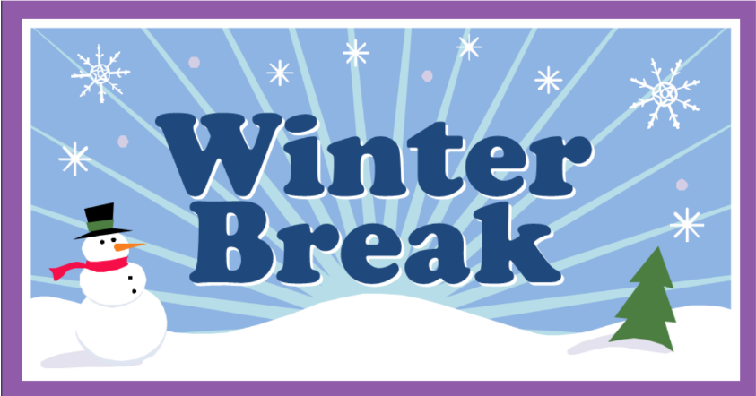

PRINCE GEORGE’S COUNTY PUBLIC SCHOOLS
Office of Academic Programs
Department of Curriculum and Instruction

™

Math 7 Winter Enrichment Choice Board
Answer Key

Activity 1
See activity directions and rubric.

Activity 2
3,760 + 2,301 + 1,855 = 7,916 total box tops

3760/7916 = 47.5 percent 2301/7916 = 29.1 percent 1855/7916 = 23.4 percent

To have the money reflected of the number of the box tops collected, the money should be split this way:
Class X: 600 x 0.475 = $285
Class Y: 600 x 0.291 = $174.60
Class Z: 600 x 0.234 = $140.40

Activity 3
See activity directions and rubric.

Activity 4
Student answers will vary. See activity directions and rubric.

Activity 5
1. Balance after one month: 3.45 (4.20 – 3.45 = 0.75 monthly charge)
Balance after two months: 3.45 – 0.75 = 2.70
Balance after three months: 2.70 – 0.75 = 1.95

2. 3 month balance: 1.95. 1.95 – 0.75 = 1.20 (balance after 4 months)
1.20 – 0.75 = 0.55 (after 5 months)
0.55 – 0.75 = -0.20 (zero balance after 6 months and card is deactivated)

Activity 6
1. (-2) + 5 = 3
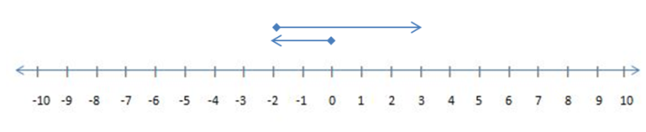

2. (-5) + 2 = -3
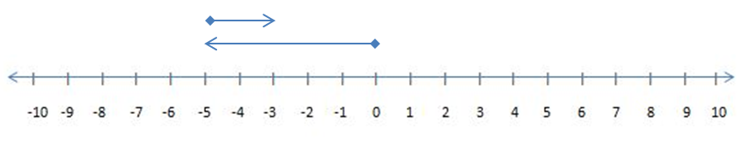

3. (-5) + (-2) = -7
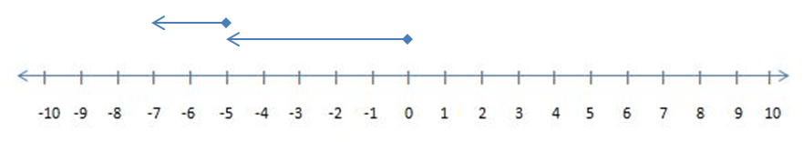

Activity 7
Student answers will vary. See activity directions and rubric.

Activity 8
Puzzle Time answer: THE CLOCK IN THE CAFETERIA THAT WAS SLOW BECAUSE EVERY DAY AT LUNCH IT WENT BACK FOR SECONDS.

Activity 9
Student answers will vary. See activity directions and rubric.

