**Government H.S.A.**

**Winter Student Enrichment Packet**

**Answer Key**

**MCBL00660_0000[1]**

***10th Grade***

**Local, State, and National**

**Government**

**™**

**Prince George’s County Public Schools**

**Office of Academic Programs**

**Department of Curriculum and Instruction**

**SKILLS AND AREAS ASSESSED BY THE GOVERNMENT H.S.A.**

Several skill areas are needed to successfully complete the Government H.S.A. Students must be able to understand and interpret items such as:

Charts

Graphs

Maps

Current Events

Primary Sources

Political Cartoons

Students will also be expected to recall key information, use problem-solving skills, and analyze issues.

|  |  |
| --- | --- |
| **AREAS TESTED BY THE GOVERNMENT H.S.A.** | |
| **Core Learning Goal 1** | **Political Systems** |
| The student will demonstrate an understanding of the historical development and current status of principles, institutions, and processes of political systems. | |
| **Core Learning Goal 2** | **Peoples Of The Nation And World** |
| The student will demonstrate an understanding of the history, diversity, and commonality of the peoples of the nation and world, the reality of human interdependence, and the need for global cooperation, through a perspective that is both historical and multicultural. | |
| **Core Learning Goal 3** | **Geography** |
| The student will demonstrate an understanding of geographic concepts and processes to examine the role of culture, technology, and the environment in the location and distribution of human activities throughout history. | |
| **Core Learning Goal 4** | **Economics** |
| The student will demonstrate an understanding of the historical development and current status of economic principles, institutions, and processes needed to be effective citizens, consumers, and workers. | |

**Note the changes**

**STUDENT RESPONSES AND THE SOCIAL STUDIES RUBRIC**

Writing is a performance activity that allows students to reflect and elaborate on how they think and what they know. It is important to extend understanding of the expectations of the rubric with repeated opportunities to write 5-7 minute Constructed Responses. The Social Studies Rubric is used with every writing assignment. Writing has been reinstated on the Government H.S.A.

**Answers that include specific details and historical or contemporary applications demonstrate “powerful and insightful” responses and help students to recognize view points and make inferences on what they have read.** Exemplars for CR items can be found on [www.mdk12.org](http://www.mdk12.org).

The rubric on the next page includes “observations” to assist students in better understanding each level. Please carefully note the differences between a Level 4 and Level 3 answer—go for the 4!

**The Social Studies Rubric**

**Scoring**

**Guide**

**For BCRs**

**A**

**9,10 out of 10**

**90 to 100**

**B**

**7,8 out of 10**

**80 to 89**

**C**

**5,6 out of 10**

**70 to 79**

**D**

**3,4 out of 10**

**60 to 69**

E

0-2 out of 10

59 and below

|  |
| --- |
| **Level 4** |

The response shows understanding of the content, question, and/or problem. The response is insightful, integrates knowledge, and demonstrates powerful application.

* The application shows powerful evidence of higher order thinking skills.
* Concepts are accurate and well supported.
* There are no misconceptions.
* The response is comprehensive.

***Observations: The response includes more than one technique of H.O.T.S. (Higher Order Thinking Skills) and contains several examples that enrich the explanation. The response integrates the bullets and does not treat each bullet as a separate question*.**

|  |
| --- |
| **Level 3** |

The response shows some understanding of the content, question, and/or problem. The response includes appropriate application that demonstrates evidence of higher order thinking skills.

* The application shows some evidence of higher order thinking skills (HOTS).
* Concepts are accurate and supported.
* There are no interfering misconceptions.
* The response may not develop all parts equally.

***Observations: The response answers the question of HOW IT WORKS or the SO WHAT part of a response.* A 3 answer has a good foundation of knowledge and builds the sides of the house with H.O.T.S. as support.**

|  |
| --- |
| **Level 2** |

This response shows knowledge of the content, question, and/or problem. The response is acceptable with some key ideas. The response shows little or no evidence of application.

* The response includes some basic ideas.
* The response provides little or no support.
* There are minimal misconceptions.

***Observations: This response has some meat on the bones or skeleton of ideas.***

|  |
| --- |
| **Level 1** |

The response shows minimal knowledge of the content, question, and/or problem. The response is related to the question, but is inadequate.

* The response includes incomplete or fragmented ideas or knowledge.
* There may be significant misconceptions.

***Observations: This response has a skeleton of idea(s). The answer needs to include a new piece of information and not simply restate the prompt or form an opinion without any new knowledge.***

|  |
| --- |
| **Level 0** |

The response is completely incorrect or irrelevant.

**Selected Response Questions**

**DIRECTIONS**: Read each question carefully. Circle the correct answer.

1. The Fifth Amendment protects many rights. It also defines the power of the government to take private property for public use. This power or right is called

CLG

1.1.2

Unit II

A Concurrent powers

B Revitalization

C Rule of law

**D Eminent domain (*This is the correct answer.*)**

**Student response will vary:** ***A-*** *It could not be concurrent powers because the question did not ask anything about levels of government having the same power (taxing).* ***B-*** *Revitalization is when a neighborhood is being built up to better the community/economy.* ***C-*** *Rule of law, when the government must follow the same rules/laws as citizens do.* ***D-*** *Eminent Domain is the correct answer because it is listed in the 5th Amendment as a right to citizens having “just compensation” for land if it is taken by government. Definition of eminent domain- the power of government to take private property for public use. (This term is also an assessment limit- one of those words I need to know to pass the H.S.A.)*

1. In which form of government do sovereign states have more power than the central government?
2. Federal

CLG

2.2.1

Unit I

1. **Confederate**
2. Authoritarian

J Unitary

1. Which of these is an economic goal of United States’ government policy?

A To limit competition

CLG

4.1.1

Unit 1

B To create a classless society

**C To promote full employment**

D To own the means of production

***Student Reflection Responses will vary for all Selected Response Questions.***

1. “We the People…” as stated in the preamble of the Constitution states that our constitution is based on rule of the people. Identify the principle of government in which the preamble is supported.

**F****Popular sovereignty**

CLG

1.1.2

Unit II

G Rule by law

H Limited government

J Articles of Confederation

1. Identify the system of government that divides power between the Federal government and State governments.

CLG

1.1.1

Unit I, II

1. Communism
2. Constitutionalism
3. Republicanism
4. ***Federalism***
5. The Fourth Amendment protects citizens from unreasonable search and seizure. This is an example of:

CLG

1.1.1

Unit I, II

1. Delegated power
2. Judicial review
3. General welfare

**J *Limited government***

1. Changes to the Constitution allow the document to reflect how our nation transforms over time. These changes are called:

CLG

1.1.1

Unit I, II

1. ***Amendments***
2. Clauses
3. Laws
4. Articles
5. Which of these best describes the main purpose of an interest group?
6. ***To influence government officials on specific issues***

CLG

1.1.4

Unit III

1. To form legislative committees that study public policy
2. To regulate the economy by setting federal lending rates

J To select cases for hearing in appeals courts

1. Which of these would be an opportunity cost to a government offering a tax break to businesses that invest in new machinery?

A An increase in industrial innovation

CLG

4.1.2

Unit I

B An increase in industrial productivity

C A decrease in the quality of goods exported

**D** ***A decrease in the amount of money collected***

***Student Reflection Responses will vary for all Selected Response Questions.***

1. Which of these identifies a major weakness of the national government under the Articles of Confederation?

**F *Lack of authority to regulate interstate trade***

CLG

1.1.1

Unit I, II

G Unequal representation of the states

H Power to violate individual rights

J Combination of executive and judicial functions in a single branch of government

1. Which political institution in Maryland would serve the same purpose as the United States Congress?

AState Archives

CLG

1.1.2

Unit II

BGeneral Court

CCourt of Appeals

**D*****General Assembly***

1. The Maryland State Highway Administration is considering a plan to widen three miles of a major route from two lanes to six lanes. Which of these most likely caused this planned action?

CLG

1.1.2

Unit II

F A decrease in trucking

**G** ***An increase in population***

H An increase in unemployment rates

J A decrease in construction work

**Direction:** Read the quote below and answer the question to follow.

**“…in all that people can individually do for themselves, government ought not to interfere.”**

***Abraham Lincoln***

13. Which of these constitutional principles best applies to this quote?

A Rule of Law

CLG

1.1.1

Unit I, II

B Due Process

***C*** ***Limited Government***

D Separation of Powers

***Student Reflection Responses will vary for all Selected Response Questions.***

14. Congress passed a law that requires states to make voting aids or individual assistance available to the disabled and the elderly.

CLG

1.2.2

Unit IV

Which of these is most likely a result of this law?

***F***  ***Voters may request ballot instructions in large print***

G Voters must vote in the precinct in which they live

H Election officials may ask a voter for identification

J Voting precincts must extend voting hours

15. Which of these is an example of lobbying by a special interest group?

A A hotel association develops a plan to attract more tourists

***B An animal rights organization presents its view to a legislator***

C A group of citizens asks city officials for a schedule of public hearings

D A neighborhood association backs a group of candidates for an election

**Read the excerpt below.**

**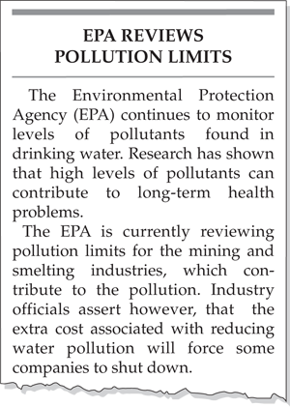**

CLG

3.1.2

Unit IV

16**. Which of these statements is best supported by the excerpt above?**

1. Government agencies have little interest in private industry.
2. **Government policy must balance health and economic concerns.**
3. The government should help fund mining and smelting industries.

J The government should allow industries to set their own environmental regulations.

***Student Reflection Responses will vary for all Selected Response Questions.***

**Study the information below. Then answer Numbers 17 and 18.**

**Executive Order 9981 (1948)**

“There shall be equality of treatment…for all persons in the armed forces…”

#### 

**Executive Order 11141 (1964)**

“[The government shall] assure that older people are not discriminated against because of their age…”

**Executive Order 11246 (1965)**

“The government…[will] provide equal opportunity in Federal employment for all qualified persons…”

CLG

1.1.3

Unit V

#### 17. What is the intent of each of these executive orders?

#### A to guarantee the safety of the people

#### B to maintain public order

#### *C to protect the rights of individuals and groups*

#### D to respect the constitutional rights of states

Reflection: Justify why you chose your answer \_\_\_\_\_\_\_\_\_\_\_\_\_\_\_\_\_\_\_\_\_\_\_\_\_\_\_\_\_\_\_\_\_\_\_\_\_

\_\_\_\_\_\_\_\_\_\_\_\_\_\_\_\_\_\_\_\_\_\_\_\_\_\_\_\_\_\_\_\_\_\_\_\_\_\_\_\_\_\_\_\_\_\_\_\_\_\_\_\_\_\_\_\_\_\_\_\_\_\_\_\_\_\_\_\_\_\_\_\_\_\_

CLG

1.2.3

Unit V

\_\_\_\_\_\_\_\_\_\_\_\_\_\_\_\_\_\_\_\_\_\_\_\_\_\_\_\_\_\_\_\_\_\_\_\_\_\_\_\_\_\_\_\_\_\_\_\_\_\_\_\_\_\_\_\_\_\_\_\_\_\_\_\_\_\_\_\_\_\_\_\_\_\_

#### 18. Which of these executive orders is most similar to the executive orders listed above?

#### *F to guarantee the safety of the people*

#### G to maintain public order

#### H to protect the rights of individuals and groups

#### J to respect the constitutional rights of states

Reflection: Justify why you chose your answer \_\_\_\_\_\_\_\_\_\_\_\_\_\_\_\_\_\_\_\_\_\_\_\_\_\_\_\_\_\_\_\_\_\_\_\_\_

\_\_\_\_\_\_\_\_\_\_\_\_\_\_\_\_\_\_\_\_\_\_\_\_\_\_\_\_\_\_\_\_\_\_\_\_\_\_\_\_\_\_\_\_\_\_\_\_\_\_\_\_\_\_\_\_\_\_\_\_\_\_\_\_\_\_\_\_\_\_\_\_\_\_

\_\_\_\_\_\_\_\_\_\_\_\_\_\_\_\_\_\_\_\_\_\_\_\_\_\_\_\_\_\_\_\_\_\_\_\_\_\_\_\_\_\_\_\_\_\_\_\_\_\_\_\_\_\_\_\_\_\_\_\_\_\_\_\_\_\_\_\_\_\_\_\_\_\_

***Student Reflection Responses will vary for all Selected Response Questions.***

**DIRECTIONS:** Examine the circle graphs below and answer the question that follows.

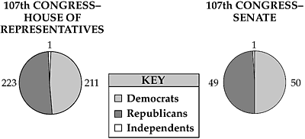

CLG

1.1.4

Unit III

19. **Based on the circle graphs, which of these statements is the most accurate?**

1. The Democratic Party has enough votes to amend the Constitution.
2. The Republican Party has enough votes to override a Presidential veto.
3. **The Democratic and Republican Parties must work together to pass legislation.**
4. The Democratic and Republican Parties have enough votes to appoint a Supreme Court Justice.

***Student Reflection Responses will vary for all Selected Response Questions.***

**DIRECTIONS:** Examine the information presented and then answer the selected response question and brief constructed response question.

**Apathy Among American Voters**

The history of the Unites States is based on democracy. Democracy, in turn, is founded on the idea that supreme authority rests with the people, who express their opinions and desires primarily through voting. Low voter turnout in some recent elections seems to signal a state of apathy [a lack of interest] among voters. In addition, fewer and fewer citizens take part in political activities such as volunteering for campaigns.

Analyze the cartoon below and then answer the question.

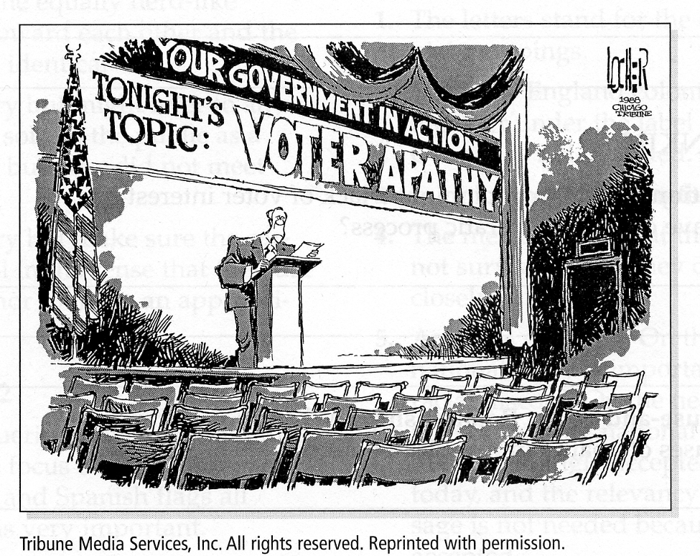

20. How does the cartoonist make his point about voter apathy?

CLG

1.1.4

Unit III

F The decorations of the hall where the speech will be given

G The location of the speaker in the room

H The banner that reads “Voter Apathy”

***J No one came to hear the speech***

***Student Reflection Responses will vary for all Selected Response Questions.***

21. Which of these excerpts from the Constitution describes federalism?



CLG

1.1.1

Unit I, II

A

**B**

C

D

Reflection: Justify why you chose your answer \_\_\_\_\_\_\_\_\_\_\_\_\_\_\_\_\_\_\_\_\_\_\_\_\_\_\_\_\_\_\_\_\_\_\_\_\_

\_\_\_\_\_\_\_\_\_\_\_\_\_\_\_\_\_\_\_\_\_\_\_\_\_\_\_\_\_\_\_\_\_\_\_\_\_\_\_\_\_\_\_\_\_\_\_\_\_\_\_\_\_\_\_\_\_\_\_\_\_\_\_\_\_\_\_\_\_\_\_\_\_\_

\_\_\_\_\_\_\_\_\_\_\_\_\_\_\_\_\_\_\_\_\_\_\_\_\_\_\_\_\_\_\_\_\_\_\_\_\_\_\_\_\_\_\_\_\_\_\_\_\_\_\_\_\_\_\_\_\_\_\_\_\_\_\_\_\_\_\_\_\_\_\_\_\_\_

**Read the excerpt below.**

**“The right of citizens… to vote shall not be denied… on account of race, color or previous condition of servitude.”**

CLG

1.1.1

Unit I, II

***—U.S. Constitution,  
Amendment 15***

22. **Which of these principles of government is reflected in this amendment?**

1. judicial review
2. federalism
3. separation of powers

**J popular sovereignty**

Reflection: Justify why you chose your answer \_\_\_\_\_\_\_\_\_\_\_\_\_\_\_\_\_\_\_\_\_\_\_\_\_\_\_\_\_\_\_\_\_\_\_\_\_

\_\_\_\_\_\_\_\_\_\_\_\_\_\_\_\_\_\_\_\_\_\_\_\_\_\_\_\_\_\_\_\_\_\_\_\_\_\_\_\_\_\_\_\_\_\_\_\_\_\_\_\_\_\_\_\_\_\_\_\_\_\_\_\_\_\_\_\_\_\_\_\_\_\_

**Read the quotation below.**

**“…government of the people, by the people, for the people…”**

***—Abraham Lincoln, Gettysburg Address, 1863***

23. Which type of government does Abraham Lincoln describe?

***A*** ***democracy***

CLG

1.1.1

Unit I, II

B dictatorship

C monarchy

D oligarchy

Reflection: Justify why you chose your answer \_\_\_\_\_\_\_\_\_\_\_\_\_\_\_\_\_\_\_\_\_\_\_\_\_\_\_\_\_\_\_\_\_\_\_\_\_

\_\_\_\_\_\_\_\_\_\_\_\_\_\_\_\_\_\_\_\_\_\_\_\_\_\_\_\_\_\_\_\_\_\_\_\_\_\_\_\_\_\_\_\_\_\_\_\_\_\_\_\_\_\_\_\_\_\_\_\_\_\_\_\_\_\_\_\_\_\_\_\_\_\_

24. The U. S. Constitution corrected a weakness of the Articles of Confederation by

F establishing a national legislature

G allowing state governments to have power

CLG

1.1.1

Unit I, II

H requiring that amendments be approved by the states

***J giving the national government the power to collect taxes***

Reflection: Justify why you chose your answer \_\_\_\_\_\_\_\_\_\_\_\_\_\_\_\_\_\_\_\_\_\_\_\_\_\_\_\_\_\_\_\_\_\_\_\_\_

\_\_\_\_\_\_\_\_\_\_\_\_\_\_\_\_\_\_\_\_\_\_\_\_\_\_\_\_\_\_\_\_\_\_\_\_\_\_\_\_\_\_\_\_\_\_\_\_\_\_\_\_\_\_\_\_\_\_\_\_\_\_\_\_\_\_\_\_\_\_\_\_\_\_

25. The mass media is sometimes referred to as the “fourth branch of government” because it:

A endorses all government policies

CLG

1.1.4

Unit III

***B influences public opinion***

C is a powerful federal agency

D is paid for with federal taxes

Reflection: Justify why you chose your answer \_\_\_\_\_\_\_\_\_\_\_\_\_\_\_\_\_\_\_\_\_\_\_\_\_\_\_\_\_\_\_\_\_\_\_\_\_

\_\_\_\_\_\_\_\_\_\_\_\_\_\_\_\_\_\_\_\_\_\_\_\_\_\_\_\_\_\_\_\_\_\_\_\_\_\_\_\_\_\_\_\_\_\_\_\_\_\_\_\_\_\_\_\_\_\_\_\_\_\_\_\_\_\_\_\_\_\_\_\_\_\_\_\_\_\_\_\_

**DIRECTIONS:** Carefully read each stimulus and then fully complete the tasks given. Write your CR answer in the answer box provided on the next page.

Read the quote below to answer the following question.

**“Some lawmakers wish to censor music lyrics that encourage**

**violence and destructive behavior."**

CLG

1.1.1

Unit I, II

What possible reasons could some lawmakers have in wanting to censor music?

* Based on what you know about the Bill of Rights, do you believe this type of censorship is constitutional? Explain why or why not.
* Include details and examples to support your answer.

Anchor Paper Rated a 4 by MSDE. Sample response:

*Some lawmakers and political action groups want to censor music lyrics because they believe the lyrics cause young people to commit acts of violence. I believe that censoring music lyrics is not constitutional. The First Amendment guarantees the right to freedom of expression. Freedom of speech is part of that. As long as the lyrics are not slander, they are covered under the First Amendment.*

*Some people feel that certain music artists, like Marilyn Manson, write lyrics that convince young people to kill others or themselves. Artists might include such lyrics, but just because someone tells you to jump off a bridge, does that mean you should jump? I don’t think so. There are millions of kids that will listen to the same lyrics and most appreciate the music and lyrics for what they are: entertainment and an outlet for the artist and listener. As an outlet and form of entertainment, music lyrics fall under freedom of expression and should be protected by the First Amendment. Censoring music lyrics should be a personal, family choice, not a government law.*

**Vocabulary Development Founding Documents**

**Creating Useful Study Aids to compare Founding Documents use with Chapter 2 of Textbook**

*Adapted from the Dinah Zike United States Government Reading and Study Skills*

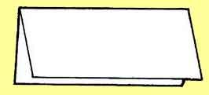

**Step 1**

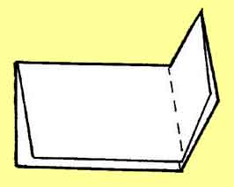

**Step 2**

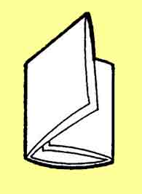

**Step 3**

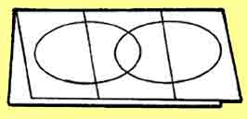

**Step 4**

**Instructions for a Three-Tab Book Venn Diagram:**

**1.** Fold a sheet of paper in half like a hot dog.

**2.** With the paper horizontal, fold the right edge toward the center, trying to cover one half of the paper.

**3**. Fold the left side over the right and crease to form three tabs.

**4**. Draw two overlapping ovals on the front (see step 3) and use the provided template. Write the word “**Both**” in the center of both ovals. On each oval write the following words:

**Articles of Confederation**

**U.S. Constitution**

**5**. Cut up the two valleys on one side only.

Inside the folded diagram, write out the major points for the Articles of Confederation and the US Constitution (their differences). In the center, write out the similarities of the two documents.

**Three-Tab Book Venn Diagram Template**

**Fold Here**

**Label** ***Articles of Confederation***

**Cut Here**

**Label** ***Both***

**Cut Here**

**Label *US Constitution***

**Vocabulary Development for Constitutional Freedoms**

**Creating Useful Study Aids to compare First Amendment Clauses use with Chapter 13 of Textbook**

*Adapted from the Dinah Zike United States Government Reading and Study Skills*



**Step 1**



**Step 2**



**Step 3**



**Step 4**

**Instructions for a Three-Tab Book Venn Diagram:**

**1.** Fold a sheet of paper in half like a hotdog. Leave a 1-inch margin for labeling.

**2.** With the paper horizontal, fold the right edge toward the center, trying to cover one half of the paper.

**3.** Fold the left side over the right and crease to form three tabs.

**4.** Draw two overlapping ovals on the front (see step 3) and use the provided template. Write the word “**Both**” in the center of both ovals. On each oval write the following words:

**The Establishment Clause**

**The Free Exercise Clause**

**5.** Cut up the two valleys on one side only.

Inside the folded diagram, write out a brief definition of the establishment clause and list the ways it differs from the free exercise clause. On the right tab, do the same for the free exercise clause. In the center oval, list ways both clauses protect freedom of religion.

**Three-Tab Book Venn Diagram Template**

**Fold Here**

**Label** **Establishment Clause**

**Cut Here**

**Label** ***Both***

**Cut Here**

**Label Free Exercise Clause**

**10th Grade**