Grade 7
Science
SPRING ENRICHMENT PACKET
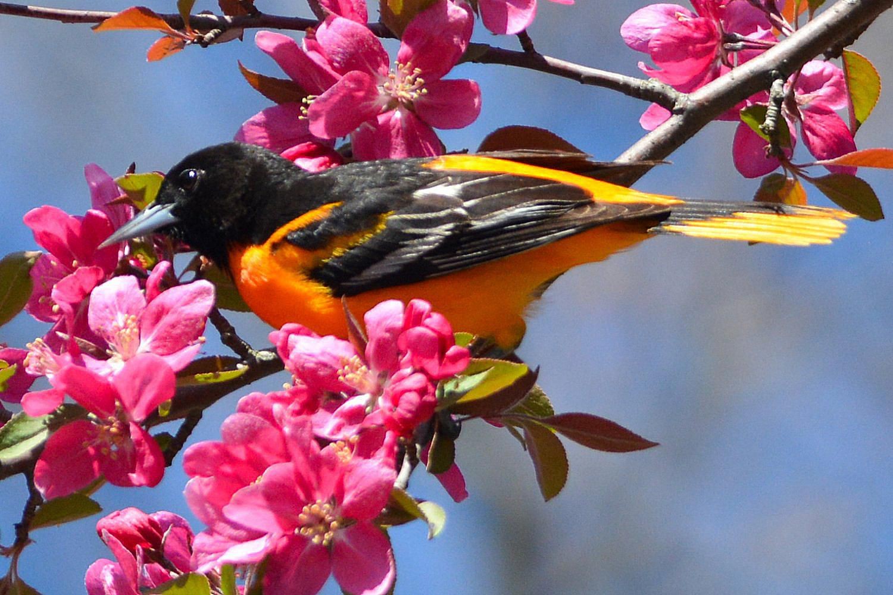

Prince George’s County Public Schools
Office of Academic Programs
Department of Curriculum and Instruction

Note to Student and Parents/Guardians

This is an “at-home” supplemental science instructional packet for middle school students during Spring Break.

This packet has been created to provide practice for students to answer Selected Response (SR) items and work through technical reading passages of informational text to write Constructed Responses (CRs) to support middle school science and the PGCPS Literacy Initiative. For Constructed Response items, it is highly recommended that students practice their annotating skills when reading the text.

Students will use the passages to write claims, evidence, and reasoning for Constructed Response items and circle the correct answer choice for Selected Response items.

- For more information about the PGCPS Literacy Initiative, visit: http://www.pgcps.org/literacy/ for parents and students.

The items in the Spring Enrichment Packet are aligned to the Next Generation Science Standards’ (NGSS) Science and Engineering Practices (SEPs).

For more information about the PGCPS Science and NGSS, visit:
- PGCPS Science Department: http://www1.pgcps.org/science/
- NGSS Website: https://www.nextgenscience.org/
- NGSS Parent Guide: https://tinyurl.com/NGSSParentGuide

The answer key for SR items and the writing rubric for CR items are located on pages 8 and 9.
Science and Engineering Practices

Use the information below to answer Number 1.
- Grace's class measured the temperature outside four times a day for four days in a row. Their results are shown below.
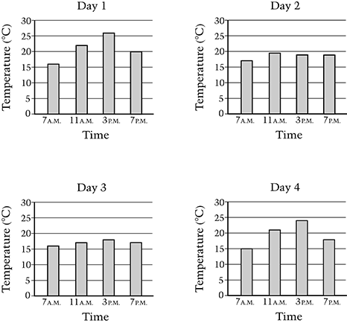
Based on these data, which two days were most likely cloudy?

- Days 1 and 2

- Days 2 and 3

- Days 3 and 4

- Days 1 and 4

2. You have run several trials in your experiment and gathered data from each trial.

What will help you organize all the information from your experiment?

- develop a hypothesis

- create a table or a graph

- run some more trials

- draw your conclusion

Use the information below to answer Number 3.

Rafael lives near a road at the bottom of a hill. His parents are concerned that soil will wash off the hill and rocks will fall onto the road. Rafael conducts an investigation to find out if grass growing on a hillside will help stop soil erosion. He collects two samples of the same size and type of soil. One sample of soil has grass growing on it and the other does not. He places each sample of soil in a small tray.

After pouring the water onto both pieces of soil, Rafael makes an observation. The water collected in the tray under the soil with grass looks clearer than the water collected in the tray under the soil without grass.

3. What conclusion can Rafael make from his observation?

- The grass helped to hold the soil in place.

B. The grass helped to move the water through the soil.

C. The soil without grass was sticky, so more water stayed in the soil.

D. The soil without grass was loose, so more water stayed in the soil.

Use the information and table below to answer Number 4.

4. You are helping a friend with a lab report. He tells you that he has discovered that tomato plants grow better in moist soil than in dry soil. You look over the experimental design and see the table below.

Experimental Design

Number of Plants | Soil Type | Garden Location
20 | dry | sunny
25 | moist | part shady

Evaluate your friend’s experimental design.

In your response, be sure to include:

- the list of variables in the experiment
- validity of your friend’s conclusion
- a description on how you would change the experiment

Write your answer in the space provided.

Use the information and table below to answer Number 5.

5. Two students investigated the growth of pea plants. Each student had three pots. All of the pots contained the same type and amount of soil. They planted pea seeds in each pot. The students set up their investigations as shown in the table below.

Explain which student had the best setup to find out how the amount of sunlight affects the growth of pea plants.

In your response, be sure to identify the independent and dependent variables.

Student Name | Volume of Water  Added to Pots | Temperature of  the Environment | Amount of Sunlight Pots Received
Michael | The same for each pot | Different for each pot | The same for each pot
Carmen | The same for each pot | The same for each pot | Different or each pot

Write your answer in the space provided.

Use the diagram below to answer Number 6.

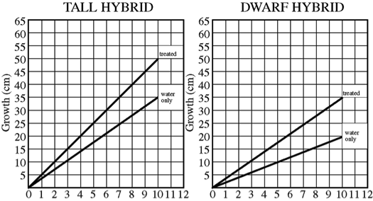

6. In an experiment to study the effect of a new fertilizer on the growth of tall hybrid corn and dwarf hybrid corn, from immediately after germination to ten days of growth, the data above were obtained. Other growing conditions such as water and sunlight were the same for both groups.

Which of the following is the most reasonable conclusion that can be drawn from the data above?

- The new fertilizer influences the growth of both corn varieties tested.

- The new fertilizer causes faster growth rate for both varieties than do other fertilizers.

- The new fertilizer improves the root system of the tall hybrid to a greater extent than it does that of the dwarf hybrid.

- The new fertilizer is effective in producing faster growth for both varieties for the first ten days only.

Answer Key

- B.
- B.
- A.
- USE THE WRITING RUBRIC ON PAGE 9 TO SCORE
SAMPLE STUDENT RESPONSE: The variables in the experiment include the soil type, amount of light, and the number of plants. The conclusion was not valid because other variables were not controlled like the soil type and the plant location. The experiment can be changed by making sure that both batches of tomato plants be in the same location and only one soil type will be used.

- USE THE WRITING RUBRIC ON PAGE 9 TO SCORE
SAMPLE STUDENT RESPONSE: The dependent variable for both set ups is pea plant growth. In Michael’s setup, the independent variable is temperature. In Carmen’s setup, the independent variable is sunlight. Because the question asks them to determine how the amount of sunlight affects the growth of the plant, Carmen’s set up is the best. Carmen has the best set up to find out how the amount of sunlight affects the growth of pea plants.

- A

MISA 4-POINT RUBRIC
Rubric derived from the Maryland State Department of Education for use with Maryland Integrated Science Assessment (MISA).

Score Point 4
There is evidence in this response that the student has a full and complete understanding of the solution to a problem or constructs a full and complete explanation of the question.
- Demonstrates complete integration of the use of science and engineering practices such as modeling, engaging in argument from evidence, obtaining, evaluating, and communicating information, etc.
- Provides a solution or explanation that is coherent and based on disciplinary core ideas
- Reflects a complete synthesis of understanding of complex ideas and crosscutting concepts
- Includes an effective application of the 3 dimensions (SEP, DCI, and CCC) to a practical problem or real-world situation which demonstrates a complete understanding of the 3 dimensions
Score Point 3
There is evidence in this response that the student has a general understanding of the solution to a problem or constructs a complete explanation of the question.
- Demonstrates integration of the use of science and engineering practices such as, modeling, engaging in argument from evidence, obtaining, evaluating, and communicating information, etc.
- Provides a solution or explanation that is mostly coherent and based on disciplinary core ideas
- Reflects a synthesis of understanding of complex ideas and crosscutting concepts
- Includes an effective application of the 3 dimensions to a practical problem or real-world situation which demonstrates an understanding of the 3 dimensions

Score Point 2
There is evidence in this response that the student has a partial understanding of the solution to a problem or constructs an explanation of the question.
- Demonstrates some integration of the use of science and engineering practices such as, modeling, engaging in argument from evidence, obtaining, evaluating, and communicating information, etc.
- Provides a solution or explanation that is adequately coherent and based on disciplinary core ideas
- Reflects some synthesis of understanding of complex ideas and crosscutting concepts
- Includes an application of the 3 dimensions to a practical problem or real-world situation which demonstrates a partial understanding of the 3 dimensions

Score Point 1
There is evidence in this response that the student has a minimal understanding of the solution to a problem or constructs a minimal explanation of the question.
- Demonstrates little or no integration of the use of science and engineering practices such as, modeling, engaging in argument from evidence, obtaining, evaluating, and communicating information, etc.
- Provides a solution or explanation that is minimally based on disciplinary core ideas
- Reflects little or no synthesis of understanding of complex ideas and crosscutting concepts
- Includes an application of the 3 dimensions to a practical problem or real-world situation which demonstrates a minimal understanding of the 3 dimensions

Score Point 0
There is evidence that the student has no understanding of the solution to a problem or the question.
- The response is completely incorrect, too vague, or irrelevant to the solution or question

