**SPRING STUDENT ENRICHMENT PACKET**

**RESEARCH SIMULATION TASK**

**& READING LOG**

**Grade 7**

**The Roswell Incident**

**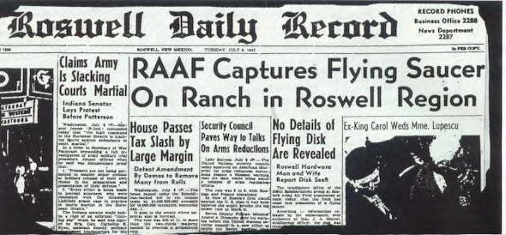**

**Reading/English Language Arts**

**™**

**Prince George’s County Public Schools**

**Office of Academic Programs**

**Department of Curriculum and Instruction**

**[Type the company address]**

**Note to Students:**

You've learned so much in school so far! It is important that you keep your brain active over the break. In this package you will find a calendar of activities to last you all Spring Break. This year we have also incorporated a fun project for you to complete. Once you have completed the activity, create a journal that you can use to note your thoughts, ideas, and any work you complete

**Directions:**

Family members should preview the packet together. There are activities that may require advance planning, or you may want to consider working together with other family and friends on some activities.

* **Students should read for at least 30 minutes each day.**
* **Students will need a Reader’s & Writer’s Journal to complete this spring work.** Your journal will be your special place for your daily calendar work and writing. Students can purchase a journal or they can make one by stapling several pieces of paper together or by using a notebook/binder with paper. Students should be creative and decorate the journal. Specific journal tasks are given some days, but students may also journal after each day's reading, notice things that stood out, questions that they have, or general wondering about the text.
* **Each journal entry should:**
* have the date and assignment title;
* have a clear and complete answer that explains the students thinking and fully supports the response; and
* be neat and organized.
* **Use the chart in this package to record all of the books read during Spring Break.**



**READING LOG**

**Ideally, students in the middle grades should read for 30 or more minutes each day.**

|  |  |  |  |  |  |  |
| --- | --- | --- | --- | --- | --- | --- |
| ***All good books are alike in that they are truer than if they had really happened and after you are finished reading one you will feel that all that happened to you and afterwards it all belongs to you…***    Ernest Hemingway  *Esquire,* December 1936  bd05509_[1] |  |  | **Day 1**  Pages Read:  Amount of Time: | **Day 2**  Pages Read:  Amount of Time: | **Day 3**  Pages Read:  Amount of Time: | **Day 4**  Pages Read:  Amount of Time: |
| **Day 5**  Pages Read:  Amount of Time: | **Day 6**  Pages Read:  Amount of Time: | **Day 7**  Pages Read:  Amount of Time: | **Additional**  Pages Read:  Amount of Time: | **Additional**  Pages Read:  Amount of Time: | **Additional**  Pages Read:  Amount of Time: | **Additional**  Pages Read:  Amount of Time: |

**Looking for a “novel” idea?** Browse your bookshelves at home for a title, or visit your local library or bookstore for a great read! If you need some ideas, a few authors are listed below.

* + Avi
  + Virginia Hamilton
  + Lois Lowry
  + Louis Sachar

**Do you prefer nonfiction?** Browse your bookshelves at home for a title, or visit your local library or bookstore for a great informational text.

* + From your World Cultures studies
  + From your Science studies
  + Current events (such as presidents and political races or global warming and other environmental issues)
  + Biographies of interesting people

**Are you still looking for ideas?**

* + Prince George’s County Memorial Library suggested reading lists by grade – <http://www.pgcmls.info/website/childrens-graded-reading-lists-442>
  + Metametrics’ Lexile website – <http://www.lexile.com/fab/>

**Introduction**

On the evening of July 2, 1947, several witnesses in and near Roswell, New Mexico, observed a disc-shaped object moving swiftly in a northwesterly direction through the sky.

In this series of tasks, you will research print and non-print media sources related to the 1947 Roswell incident and compare/contrast how information is presented. You will see how different authors choose to present their information in diverse ways.

First, you will read an article from SIRS Discover **THE CRASH AT ROSWELL: A Lingering Mystery.**Next, you will read an encyclopedia passage Roswell Incident. Then, you will watch a video **TRUE UFO STORIES: Crash in New Mexico in 1947.** (<https://www.youtube.com/watch?v=iWg9B_cbwHk&feature=youtu.be>)

Finally, you will view a website that contains an original article from the Sacramento Bee written about the 1947 Roswell Incident.

As you review these sources, think about the advantages and disadvantages of using different mediums (for example, print or digital text, video, multimedia) to present a particular topic or idea.

**Prompt:**

At the end of your simulated research, you respond to following prompt:

You have read two texts, watched a video, and viewed a website about the existence of UFOs and alien life forms.

All four texts explain the theories behind the existence of UFOs and alien life forms. However, each source suggests that the writers understood the existence of UFOs and alien life forms based upon their own observations and/or research.

Create a project that explains the various sources views on the existence of UFOs and alien life forms.

For your project, **make your own claim about the** existence of UFOs and alien life forms. Be sure to support your claim with clear reasons and supporting evidence that show how at least two of the sources add to your understanding of your claim. You should also include how one of the sources provides a counterclaim to your claim about existence of UFOs and alien life forms.

Support your response with relevant textual evidence and inferences drawn from the sources provided.

**You can produce your response to the above prompt through the following methods.**

* Essay – may type or write your response
* Prezi (<https://prezi.com/signup/public/>)
* Google Slides – available through your PGCPS Gmail account (similar tools are PowerPoint and Keynote)
* Brochure/Pamphlet
* Mock Interview with an “Expert” – videotaped or done in class after the break (<http://www.scholastic.com/teachers/lesson-plan/how-conduct-interview> )
* Mock news broadcast (like a “60 Minutes” or “Dateline” segment) – videotaped to share with your classmates

**Research Simulation Task Texts**

Four texts will be used in during the research simulation task. The print texts are included in this packet.

* Text 1: **THE CRASH AT****ROSWELL: A Lingering Mystery by Peter Eichstaedt**
* Text 2 (video): [TRUE UFO STORIES: Crash in New Mexico in 1947](https://youtu.be/iWg9B_cbwHk)

<https://www.youtube.com/watch?v=iWg9B_cbwHk&feature=youtu.be>

* Text 3: Roswell Incident from Encyclopedia Britannica
* Text 4: <http://www.ufoevidence.org/documents/doc1256.htm> (original source)

**Text 1**

**Read this text. Then answer questions 1 – 4.**

**THE CRASH AT ROSWELL**

**A Lingering Mystery by Peter Eichstaedt**

**Mystery lives in the skies over Roswell.**

1. On or about July 4, 1947, the night skies above Roswell ignited, not from a fireworks display to celebrate Uncle Sam's recent victories in Europe and the Pacific, but from a dramatic lightning storm.
2. W.W. "Mac" Brazel, the late foreman of the old Foster ranch and a neighbor of Floyd and Loretta Proctor, watched the storm that night. Brazel lived about 75 miles north of Roswell and knew he had seen more than a typical New Mexico thunder and lightning storm that night. An explosion had filled the sky and a fiery ball had plummeted to Earth.
3. The next morning, Brazel and one of the Proctor boys, William (nicknamed Dee), saddled their horses and rode out across the endless rolling grass hills to check on the flocks of sheep and to find whatever had crashed.
4. Brazel suspected the casualty was one of the planes from the U.S. Army Air Field in Roswell. Lots of strange things had been seen in the skies lately and the radio had been filled with reports of unidentified flying objects.
5. Cresting a lonely rise, Brazel found more than he bargained for: a field scattered with metallic debris and a scarred and furrowed section of earth about 12 feet deep and 150 feet long. In the distance a strange metallic object was half buried in a hillside.
6. What, in fact, Brazel and his young partner saw that day has largely been lost to history, but it continues to fascinate UFO buffs and the curious.
7. This mysterious crash and an apparent Army Air Force cover­ up has been the subject of numerous books, documentaries and most recently, a feature movie titled "Roswell," starring Martin Sheen and Kyle MacLachlan (of "Twin Peaks"), which premiered in late July on the Showtime network.
8. Loretta Proctor, who has lived 80 years in the ranch country around the small town of Corona, not far from the reputed crash site, remembers the day in July 1947, when Mac Brazel and her son rode up to the farmhouse. Mac was excited. In his saddle bags he carried a bit of the debris.
9. "All he brought was a piece about six or seven inches long," Mrs. Proctor says. She described it as tan and light, like a piece of plastic the size of a pencil. But, it was puzzling. "He said he couldn't cut it or tear it," she says. "Now we would say it was plastic. I remember him trying to cut it with a knife and burn it with a match. It looked like wood, but it wasn't. It was very strong." As the ranchers pondered this event and this material, Brazel described the rest of the debris. "He said it looked like aluminum foil. Crumple it and it would go back to its shape." The beams and other pieces had very strange markings on them, she remembered Brazel saying. "He wanted us to go out and see it."
10. Brazel decided to make the trek to Roswell and talk to Sheriff George Wilcox. When Brazel showed Wilcox a sample of the strange metallic debris and told his story, Wilcox was as baffled as anyone. But he figured that this had something to do with the Roswell base. Maj. Jesse Marcel, the base intelligence officer, was contacted and said he would come right over.
11. Meanwhile, Frank Joyce, a young reporter with the Roswell radio station KGFL and a stringer for United Press International in Santa Fe, called the sheriff looking for local news. Wilcox handed the phone to Brazel, who started talking. Joyce listened eagerly.
12. Joyce, now a retired Albuquerque television and radio broadcaster, could hardly believe what he was hearing. Brazel said he had found a flying saucer and alien bodies. "I was really shocked by this because he told it so factually," Joyce says. He also suggested Brazel inform the air base.
13. Later that day, after Marcel heard Brazel's story, they and the base's counter intelligence officer, Capt. Sheridan W. Cavitt, went out to the site, guided by Brazel. Details of the site visit remain sketchy, but the Army Air Force moved swiftly. Military police cordoned off the area and the debris field, and according to some accounts, several alien bodies were recovered and taken back to Roswell under the strictest security.
14. That night Glenn Dennis, a mortician at the Ballard Mortuary in Roswell, was called from the base and asked detailed questions about embalming. Dennis offered to help, but was flatly turned down. Dennis ended up at the base infirmary later, however. The funeral home also operated an ambulance service and an airman had been injured in a car accident. Dennis picked him up and took him to the base.
15. The base hospital was unusually busy, Dennis recalled. He noticed that one of the military trucks backed up to the loading dock was filled with chunks of metal. He commented to a soldier about a plane wreck, but was told he had to leave.
16. Dennis, a civilian who now owns an art gallery in Lincoln, instead looked for a nurse he knew. He recalls that when he found her, she was shaken and upset, and told him that he'd better leave for his own good. She agreed to meet him the next day for lunch. When they met, according to accounts provided by Dennis, she revealed that she had assisted doctors in performing an autopsy on several alien bodies and that the stench was horrible. She drew him pictures, but the pictures have been lost. That was the last Dennis saw of the mysterious nurse. He learned from friends that she had been suddenly transferred to England. He wrote to her, but his letters were returned and stamped, "deceased."
17. On July 8, 1947, Col. William H. Blanchard, the base commander, summoned his aide and public relations officer, Lt. Walter Haut, and dictated a press release that would stun the world. Blanchard announced that officials from Roswell Army Air Field had recovered a flying saucer, the crash of which had been reported by a Roswell area rancher. The recovered material had been flown to higher headquarters.
18. "He was very explicit about what he wanted in the release," Haut recalled at his home in Roswell. Haut personally delivered the release to the town's two newspapers, the ROSWELL MORNING DISPATCH and the ROSWELL DAILY RECORD, and the town's two radio stations, including KGFL where Joyce worked.
19. Now that Brazel's story had come from the Army Air Force, Joyce knew he had the hottest story of his life. He ran over to the Western Union office and sent it immediately to the UPI office in Santa Fe. The press release was issued in time for the afternoon edition of the ROSWELL DAILY RECORD, which ran the headline: "RAAF Captures Flying Saucer on Ranch in Roswell Region." The story was also picked up by the national news services and went out across the country, appearing in afternoon editions of newspapers from Chicago to San Francisco. "Action was immediately taken and the disc was picked up at the rancher's home," according to the official military statement published in the Wednesday, July 9, 1947, edition of the SAN FRANCISCO CHRONICLE.
20. But, just as the story had spread across the country, an announcement came later that same day from 8th Army Air Force headquarters in Dallas, Texas, that the material recovered was a metallic weather balloon and a flat, hexagonal radar deflector. The story quickly died.
21. That evening Brazel, went over to KGFL and talked again to Joyce. Brazel now changed his story and told Joyce that he now thought he had seen a weather balloon. Joyce remains convinced that Brazel was forced to change his story. Joyce then told the cowboy, "well, so much for the little green men."
22. Brazel wheeled around. Joyce remembers Brazel's words: "He said, `they weren't green.' That's exactly what he said. Then he said, `OK they told me to come in here and tell you about the weather balloon.'"
23. Brazel looked frightened, Joyce recalled, and warned Joyce also to stop talking about the UFO or, "it will go very hard with me...and with you." Brazel paused before he left and said, "Our lives will never be the same," according to Joyce.
24. "He was right about that," Joyce says. Joyce remembers that a few days after he talked to Brazel, he received a phone call from a colonel in the Pentagon. Joyce would not elaborate except to say, "It was a very threatening phone call."
25. Most of the Roswell UFO crash story was rarely discussed by Roswell residents who remember it until UFO researchers and writers began exploring the event. In 1980, the book, THE ROSWELL INCIDENT, first appeared in hardback and was one of the earliest attempts to unravel the mystery of what had occurred. This book was the first of many books, articles and films, and spurred a number of people to come forward who recalled or were involved in the incident.
26. Among those are people such as Bob Shirkey, who was assistant flight operations officer at Roswell at the time. Shirkey remembers being ordered to quickly arrange for the aircraft to ship the debris—and he believes the alien bodies—to Wright­Patterson Air Force Base near Dayton, Ohio.
27. "I approved several flights of stuff that went to Wright­ Patterson Field," he says. Later he learned from others that the hangar where the material went, known as Hangar 18, remained a top secret site and was heavily guarded. Shirkey also remembers seeing some of the contents of the boxes that were shipped. His descriptions—lightweight metallic material, some with strange markings—match Brazel's.
28. "They were cardboard boxes filled with scrap metal and an I­beam stuck out of one," he says. "It had markings on it." Shirkey is also convinced some alien bodies were found in the wreckage and were also shipped out. He says they were kept overnight in one of the hangars at Roswell after being examined at the base hospital. The bodies were put in sealed containers that also went to Wright­Patterson, he says.
29. One of the airmen who helped load the material and who was on one of the flights was Robert Porter, the brother of Loretta Proctor. "He expected it to be heavy. It was very light," Mrs. Proctor recalled her brother saying.
30. Despite the intense research that this topic has received, many questions still surround the supposed Roswell UFO, such as:

**Did anything really happen that night in Roswell?**

1. Most who are still alive who remember those days are convinced that a crash occurred and that the U.S. government was worried about it because of the extent to which government agents went to keep it quiet. Joyce says a day after the UPI report went out, his boss in Santa Fe said that agents went to the news office and confiscated all copies of the story that had gone out on the wire. Several years later, an FBI agent visited Joyce and warned him to not talk about the UFO incident.

**Why the secrecy?**

1. Stan Friedman, a nuclear scientist, avid UFO researcher and coauthor of the book, CRASH AT CORONA, offers one explanation. At the time of the UFO incident, the United States was riding the crest of victory in a world war fought on two fronts. The country was the sole possessor of the atomic bomb and had the most advanced technology in the world. For at least a week before the Roswell incident, UFO sightings were reported all over North America.
2. What Friedman asks, was “the U.S. government going to tell people if aliens were truly zipping around the skies? Strange objects were flying over the most powerful country on Earth at incredibly high speeds and executing bizarre maneuvers.” The government had no idea why, how or who was flying them. Friedman believes the government did not want to admit it had no idea what was going on and did not want to create panic in the general population.
3. Joyce agrees. "We were number one. There was nothing higher. But there were these objects flying around. It would be like Orson Welles and the Invasion from Mars. In Roswell there was panic in the streets."

**Why would UFOs want to fly over Roswell?**

1. One explanation is that the 509th Bomb Group, which was stationed in Roswell, was an elite group of pilots who were trained exclusively to drop atomic bombs. And the bomb had been developed and tested in New Mexico. In short, New Mexico was an excellent place for a technically advanced civilization to keep an eye on earthling technology.
2. Hope for answers to these questions surfaced in 1993 when U.S. Rep. Steven Schiff, R­N.M., asked Les Aspin, the former defense secretary, for some official answers from the Department of Defense. In his letter, Schiff noted "the inconsistency between repeated official denials, and the public record and testimony of those involved."
3. Despite his request, Schiff has only been able to elicit a promise from the federal General Accounting Office to investigate whether proper procedures were followed in the investigation and reporting of the incident.

**Is there an answer to this mystery?**

1. Possibly. But unless there is some dramatic change in attitude on the part of the U.S. government, the supposedly secret files on UFOs and events like the one in Roswell will likely remain sealed for years.
2. Mrs. Proctor, who has lived a lifetime with her questions about the crash, offers this: "There's really something to it, but I don't know if they'll ever know in my life. My idea is they (military officials) were trying to duplicate this material and didn't want anyone to know about it."

**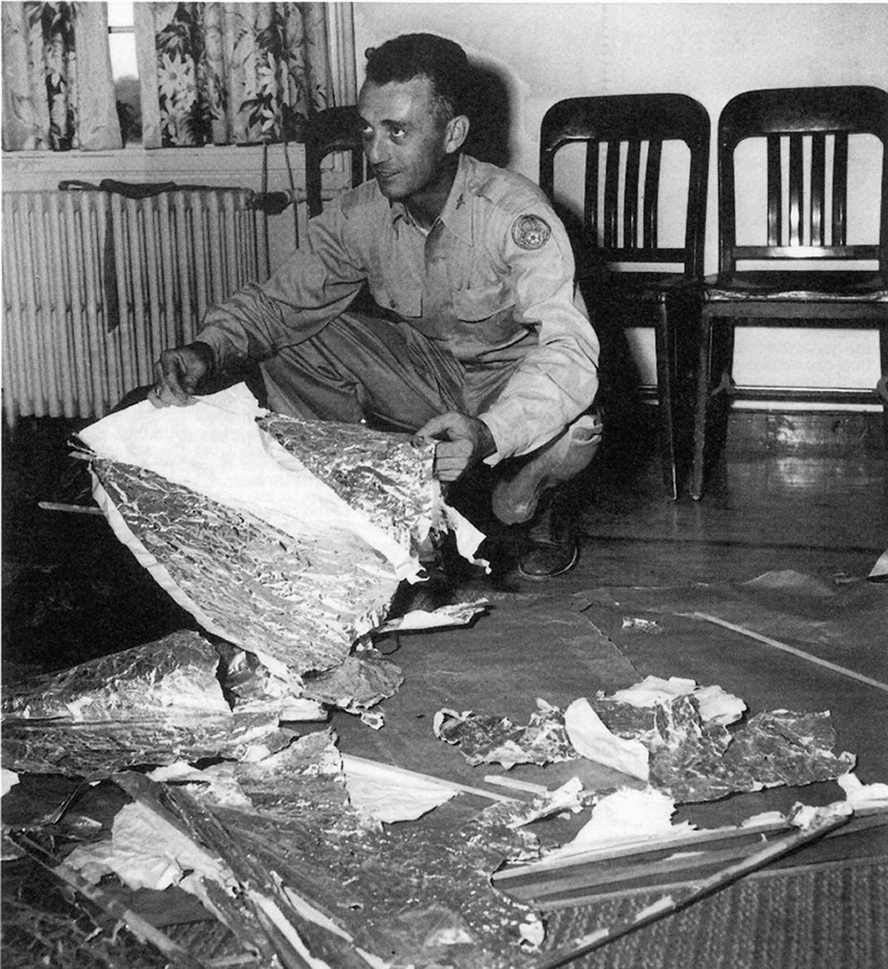**

*Major Jesse Marcel from the Roswell Army Air Field with alleged debris found 75 miles northwest of Roswell, NM, in July 1947. | Getty*

**1. Part A**

What is the meaning of **debris** as it is used in the article?

1. wreckage
2. remains
3. filth
4. fragments

**Part B**

Which phrase from the article best supports the correct answer in Part A?

1. …several alien bodies were recovered and taken back to Roswell under the strictest security.
2. …looked like aluminum foil. Crumple it and it would go back to its shape."
3. Details of the site visit remain sketchy, but the Army Air Force moved swiftly.
4. They were cardboard boxes filled with scrap metal and an I­beam stuck out of one.

**2. Part A**

Which sentence **best** states a central idea of the article?

1. The 1947 Roswell incident inspired articles and films, and spurred a number of people to come forward who recalled the incident.
2. The government hid the facts of Roswell because it would have been like Orson Welles’ radio broadcast, Invasion from Mars - panic in the streets.
3. Government officials, like U.S. Rep. Steven Schiff, want the Department of Defense to provide answers about the 1947 Roswell incident.
4. When taking a look at the famous Roswell incident of 1947, there is evidence that aliens and UFOs exist, and the government had something to hide.

**Part B**

Which paragraphs from the article provides the **best** example of the central idea in Part A?

1. paragraphs 13-16
2. paragraphs 17-21
3. paragraphs 27-30
4. paragraphs 34-36

**3. Part A**

What is the author’s purpose for including the section **Why the secrecy?**

1. To explain how powerful the U.S. was, because they had the atomic bomb.
2. To explain how the government covered the details of the 1947 Roswell incident.
3. To explain one author’s theory on why the 1947 Roswell incident had to be dismissed.
4. To explain how Orson Welles’ radio broadcast created a panic about aliens and UFOs.

**Part B**

What sentence from the section **best** supports the answer to Part A?

1. For at least a week before the Roswell incident, UFO sightings were reported all over North America.
2. Friedman believes the government did not want to admit it had no idea what was going on and did not want to create panic in the general population.
3. At the time of the UFO incident, the United States was riding the crest of victory in a world war fought on two fronts.
4. The country was the sole possessor of the atomic bomb and had the most advanced technology in the world.
5. You have just read **THE CRASH AT ROSWELL: A Lingering Mystery.** In this text, the writer develops several big ideas.

Using the chart below, select one of these ideas and analyze how it is developed over the course of this text from its beginning and how it is shaped by specific details.

Be sure to state your central idea before providing your analysis. Cite strong evidence from the text to support your analysis. You will write an objective summary after completing the chart.

|  |  |  |
| --- | --- | --- |
| **Central Idea** | | |
| Write your central idea as a sentence here: | | |
|  | | |
| **Detail #1** | Write the detail: | Write your analysis of how detail #1 develops central idea here: |
| **Detail #2** | Write the detail: | Write your analysis of how detail #2 develops central idea here: |
| **Detail #3** | Write the detail: | Write your analysis of how detail #3 develops central idea here: |

**Text 2**

**Read this text. Then answer question 5.**

##### **Roswell Incident**

From time to time in 1947, some people in various parts of the United States and some other countries reported seeing strange objects in the sky and claimed that they were spacecraft piloted by space aliens. In the midst of this “flying saucer” craze, some unusual material fell to the ground on or about July 4 near Roswell, N.M. On July 8 an eager young information officer at the Roswell Army Air Field (RAAF) issued an extraordinary and unauthorized press release. He put forth the story that a “flying disk” had been retrieved from a local ranch. The *Roswell Daily Record* immediately picked up the press release and printed the story with the headline “RAAF Captures Flying Saucer on Ranch in Roswell Region.

The young officer was reprimanded and the air base released new information stating that the “saucer” had actually been a weather balloon, or rather a cluster of balloons, carrying a radar target—a device somewhat like a box kite, made of foiled paper fastened to a balsa wood frame. The *Fort Worth Star-Telegram* published a photograph of two amused Air Force officers posing with the debris, which consisted of some flexible, silvery material. The *Roswell Daily Record* also carried the correction and featured an interview with the rancher, William (Mac) Brazel, who did not believe that the debris he discovered was from a weather balloon. (The portions of the debris most puzzling to Brazel may in fact have been from a radar target.) Soon, the story faded from public attention.

The Roswell incident, however, began to serve as the basis for hoaxes. One of the early hoaxes was the 1949 story that actual footage of a captured spacecraft would be shown in a forthcoming science-fiction film ‘The Flying Saucer'. An actor was hired to pose as an agent of the Federal Bureau of Investigation (FBI) and swear that the retrieval was true. When the producer-director was interviewed by Air Force investigators, he admitted the story was a publicity stunt. The following year a book titled ‘Behind the Flying Saucers' was published. In it the author, Frank Scully, alleged that the United States government possessed no fewer than three alien spaceships, along with the bodies of their occupants. An investigation of the facts revealed that Scully was told the story by two confidence men who were attempting to sell an oil-locating device that they claimed was based on alien technology.

During the 1970s various persons claimed to have seen the bodies of the aliens stored at one or another secret location. A major promoter of such tales was “Professor” Robert S. Carr, a spinner of yarns who, according to his son, told such stories just to make himself seem more interesting.

Then in 1980 a book titled ‘The Roswell Incident' was published. The book's coauthors, Charles Berlitz and William L. Moore, labeled the weather balloon explanation a “cover story.” They argued that the original debris, which they believed was from a crashed flying saucer, had been flown to Wright Field (later Wright-Patterson Air Force Base) near Dayton, Ohio, and material from a weather balloon was “hastily substituted.” Berlitz and Moore cited the recollections of former Roswell staff officer Major Jesse A. Marcel, who was in charge of intelligence at Roswell in 1947. He and Brazel's son described materials that resembled metallic foil, balsa sticks, and string, yet were supposedly quite technologically advanced. The authors imply that the material was of extraterrestrial origin. Unfortunately, many years had elapsed between 1947 and 1980, individual memories had perhaps become untrustworthy, and in the meantime the forces of myth-making were in operation.

Still other Roswell hoaxes included the notorious “MJ-12 documents” of 1984, which purported to show a secret operation was launched by President Truman to handle the Roswell incident; a falsified diary that surfaced in 1990, supposedly kept by a man who came upon a crashed saucer with injured aliens in 1947; a bogus alien autopsy film of 1995 purporting to show the dissection of an alien corpse; a fake Roswell UFO fragment delivered to a UFO museum in 1996; and so on. Such sensational hoaxes helped to make the term “Roswell incident” almost universally familiar to the point that it has achieved the status of myth.

Ironically, Berlitz and Moore were right about one thing: the government's claim that a weather balloon crashed at Roswell was incorrect. In 1994 the Air Force admitted that the recovered material was in reality from a United States spy balloon. Part of Project Mogul, it was an attempt to monitor anticipated nuclear tests by the Soviet Union. In 1997, a definitive Air Force report ventured the opinion that stories of alien bodies may have come from civilian witnesses who saw parachute crash test dummies, a severely injured airman parachutist, and charred bodies from an airplane crash during the 1950s. The Air Force report proposed that the witnesses “consolidated” the separate events—the Project Mogul materials, the crash test dummies, the airman, and the charred bodies—in their memories.

*Copyright © 2011 Encyclopedia Britannica, Inc*.

1. After you read the text, **Roswell Incident**, please complete the graphic organizer below.

**Part A**

Determine a central idea that is developed by the details of the letter. Write your chosen central idea as a sentence in the chart below.

**Part B**

Select three particular details that develop the central idea you determined in Part A. Write these details in the chart.

|  |  |
| --- | --- |
| **Central Idea** | |
| Write the central idea as a sentence here: | |
|  | |
| **Detail #1** | Write the detail: |
| **Detail #2** | Write the detail: |
| **Detail #2** | Write the detail: |

##### **TEXT 3**

**Watch the video then answer questions 6 – 7.**

**Video Excerpt from**

**TRUE UFO STORIES: Crash in New Mexico in 1947**

<https://www.youtube.com/watch?v=iWg9B_cbwHk&feature=youtu.be>

*HINTS: You may want to view it once to get the gist, or general idea. You can then view it a second time for deeper understanding of the information.*

*You may watch the video clip as many times as you want. However, keep in mind that you may have to complete a similar task in a timed situation. Watching the full video clip too many times can take away from your time to think and respond.*

You may take notes on the chart.

1. **Part A**

During your first viewing, watch to gain an understanding of the claims made in the video. Write one of these claims in the chart provided on the next page.

**Part B**

During your second viewing, pay attention to the reasoning and evidence used to support the claim you selected. Select three pieces of textual evidence that support the claim. Write these pieces of evidence in the chart.

**Part C**

Finally, write a brief evaluation of the claim, assessing whether the reasoning is valid and the evidence is relevant and sufficient to support the claim. Write your evaluation in the final row of the chart.

|  |  |
| --- | --- |
| **Claim** | |
| **Write claim as a sentence here:** | |
|  | |
| **Evidence #1** |  |
| **Evidence #2** |  |
| **Evidence #3** |  |
| **Evaluation** | |
| **Write evaluation of support for claim here:** | |

1. What are advantages and disadvantages of this format to present information? Use this graphic organizer to organize your thoughts about the advantages/disadvantages of the format of this form of media.

|  |  |  |
| --- | --- | --- |
| [**TRUE UFO STORIES: Crash in New Mexico in 1947**](https://youtu.be/iWg9B_cbwHk)  <https://www.youtube.com/watch?v=iWg9B_cbwHk&feature=youtu.be> | | |
| **Media format** |  | |
|  | **Evidence/Detail or Image** | **Explanation** |
| **Advantages of this format to presenting information** | **1:** |  |
| **2:** |  |
| **Disadvantages of this format to presenting information** | **1:** |  |
| **2:** |  |

**Text 4 (Website with Original Source Document)**

# ****This website has the**** original story published on July 8, 1947, in which the U.S. Army announced it had recovered a crashed flying disc near Roswell, NM. Quickly thereafter, the official Army story was changed to the "weather balloon" position.

#### Original July 8, 1947 "Army Has Flying Disc" Story (Roswell, NM) ****Sacramento Bee, July 8, 1947****

<http://www.ufoevidence.org/documents/doc1256.htm> (original source)

*You may examine the website as many times as you want. However, keep in mind that you may have to complete a similar task in a timed situation.*

1. What are advantages and disadvantages of this format to present information? Use this graphic organizer to organize your thoughts about the advantages/disadvantages of the format of this form of media.

|  |  |  |
| --- | --- | --- |
| **Army Reveals It Has Flying Disc Found On Ranch In New Mexico** | | |
| **Media format** |  | |
|  | **Evidence/Detail or Image** | **Explanation** |
| **Advantages of this format to presenting information** | **1:** |  |
| **2:** |  |
| **Disadvantages of this format to presenting information** | **1:** |  |
| **2:** |  |

**Analysis (Final Project):**

You have read two texts, watched a video, and viewed a website about the existence of UFOs and alien life forms.

All four texts explain the theories behind the existence of UFOs and alien life forms. However, each source suggests that the writers understood the existence of UFOs and alien life forms based upon their own observations and/or research.

Create a project that explains the various sources/views on the existence of UFOs and alien life forms.

For your project, **make your own claim about the** existence of UFOs and alien life forms. Be sure to support your claim with clear reasons and supporting evidence that show how at least two of the sources add to your understanding of your claim. You should also include how one of the sources provides a counter claim to your claim about existence of UFOs and alien life forms.

Support your response with relevant textual evidence and inferences drawn from the sources provided.