**Math 7**

**Spring Student Enrichment Packet**

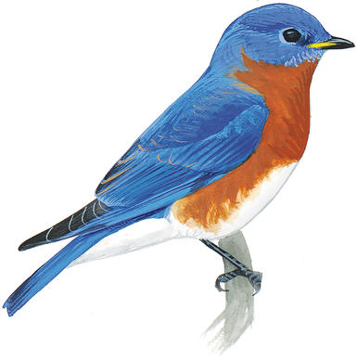

PRINCE GEORGE’S COUNTY PUBLIC SCHOOLS

Office of Academic Programs

Department of Curriculum and Instruction

**™**

***NOTE TO THE STUDENT***

*This Spring Student Enrichment Packet has been compiled to complement middle school mathematics classroom instruction aligned to the Maryland College and Career Ready Standards (MCCRS). The packet is intended to be used for* ***review and practice*** *of previously taught and new concepts.*

*The questions in this packet, which have the corresponding Maryland College and Career Ready standard listed next to them, are similar to those you will encounter later this year on the PARCC assessment. See more resources for PARCC at* [*www.parcconline.org*](http://www.parcconline.org)*.*

*We strongly encourage you to work diligently to complete the activities. You may experience some difficulty with some activities in this packet, but we encourage you to think critically and creatively and complete them to the best of your ability.*



*Use this Assessment Reference Sheet as needed as you solve the problems in this packet.*

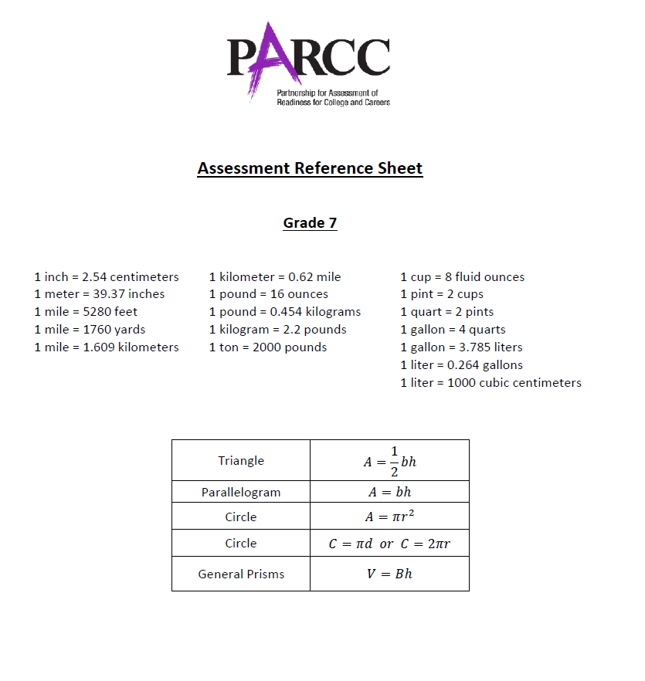

**Directions: Select or find the best answer to each problem. Write your answer in the space provided or on a separate sheet of paper.**

**1.** (7.EE.1)

Which expressions below are equivalent to $\frac{4}{3}c+5\frac{1}{3}$? Select **all** that apply.

□ A. $\frac{1}{3}(4c+16)$

□ B. $\frac{4}{3}(c+4)$

□ C. $\frac{1}{3}(\frac{3}{3}c+5)$

□ D. $\frac{2}{3}(2c+8)$

□ E. $\frac{2}{3}(3c+5)$

□ F. $\frac{4}{3}(c+5\frac{1}{3})$

**2.** (7.G.1)

On a map, the distance between St. Petersburg, Fla., and Bladensburg, Md., is shown below. If the actual distance between the two cities is 1,148 miles, then how many miles does each inch on the map represent? Write your answer in the blank below.

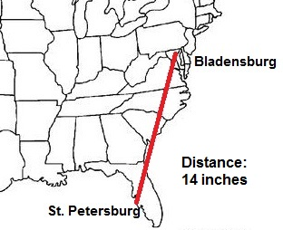

**1 inch = __________ miles**

**3.** (7.NS.3)

Caleb and his dad are preparing two flower beds in their backyard.

* A square flower bed has a side length of 5.4 feet
* A rectangular flower bed has side lengths of 3.6 feet by 8.6 feet

Caleb says the square flower bed will have a greater area. His dad says the rectangular one will have a greater area. Complete the sentence below to indicate which one has the greater area and by how much.

The flower bed has the greater area by ____________ square feet.

* square
* rectangular

**4.** (7.NS.3)

The distance between the ground and the bottom of a window is shown below. If the height of a storage container measures $\frac{5}{8}$ foot, how many containers can be stacked under the window? Enter your answer in the blank.

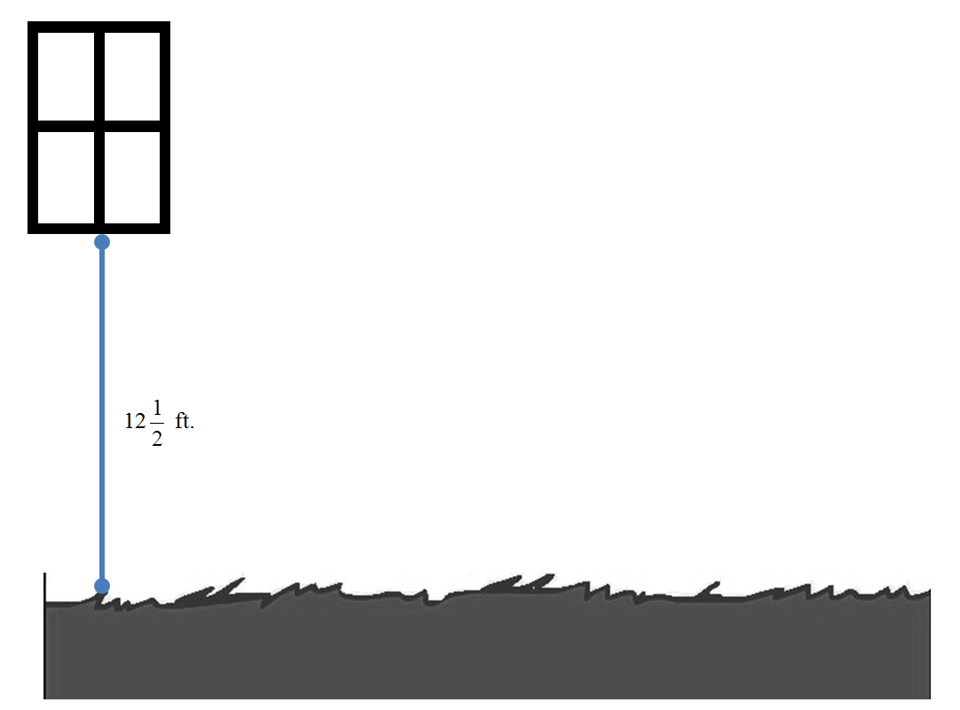

Storage Container



**______ storage containers can be stacked under the window.**

**5.** (7.NS.3)

A lacrosse coach keeps track of his players’ goals scored and total shots on goal during two practice sessions. Which player’s goal rate changed the most between Session 1 and Session 2?

|  |  |  |
| --- | --- | --- |
| **Player** | **Session 1** | **Session 2** |
| Avery | 1/3 | .375 |
| Barry | 5/8 | .655 |
| Christian | 3/20 | .170 |
| Darren | 1/4 | .255 |

A. Avery

B. Barry

C. Christian

D. Darren

**6.** (7.EE.3)

Brenda earns 1.5 times her normal hourly rate for each hour she works over 40 hours in a week. She worked 40 hours this week and earned $450. If she works 55 hours next week, how much money will she earn?

Show your work or explain your answer in the space provided.

**7.** (7.EE.4)

Jamie bought a package of notebook paper for $2.35 and some pens that cost $0.45 each. She paid a total of $6.40 for these items. How many pens did Jamie buy? Enter your answer in the box.

**pens**

**8.** (7.NS.1)

The freezing points for the following liquids are listed below.

|  |  |
| --- | --- |
| **Liquid** | **Freezing Point** |
| Fresh water | 0o C |
| Salt water (ocean) | -3.5o C |
| Antifreeze | -65o C |

Suppose the temperature has dropped to the freezing point for salt water. How many more degrees must the temperature drop to reach the freezing point for antifreeze? Enter your answer in the box.

**The temperature must drop degrees.**

**9.** (7.NS.3)

Mr. Tyson has $12,227 in his bank account on March 1st.

* He saves $734 in March.
* In April, he pays $1,306 in taxes for his businesses he owns.
* He saves $820 in May.

Select **each** statement that is true about Mr. Tyson’s account balance as of the end of May.

□ A. His account balance is approximately $1,500 greater

□ B. His account balance is approximately $250 greater

□ C. His account balance is approximately $2,500 less

□ D. His account balance is approximately $12,000

□ E. His account balance is approximately $12,500

**10.** (7.NS.1)

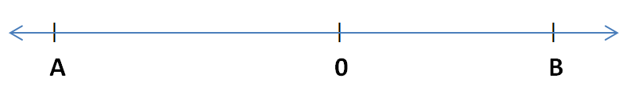

From the number line above, what is *a* + *b*?

A. zero

B. a positive number

C. a negative number

D. cannot be determined

**11.** (7.RP.2)

Some students have decided to take part in an initiative to improve their community by doing a project to plant flowers at each of the city’s parks. The number of seeds per pack and the packet price for each store are shown below.

|  |  |  |
| --- | --- | --- |
| **Go-Green** | **Giant Seeds** | **Seeds-R-Us** |
| $3.80 for 12 flower seeds | $$\frac{\$4.40}{18 flower seeds}$$ | 10 flower seeds cost $2.50 |

The students need 75 seeds for each garden. Where should they buy their seeds in order to spend the least amount of money and have the least amount of seeds left over? Show your work or explain your answer.

**12.** (7.RP.3)

Jessly and Karen are friends who live 59 miles apart. Sometimes on Saturday, they ride toward each other’s houses on their bikes and meet in between. One day they left their houses at 8 a.m. and met each other at 11 a.m. Jessly rode 11.4 miles per hour.

**Part A**

How many miles did Jessly ride? Enter your answer on the line.

**_____ miles**

**Part B**

How fast did Karen ride in miles per hour? Enter your answer below. Round your answer to the nearest hundredth if necessary.

**______ miles per hour**

**13.** (7.NS.3)

Alyssa is downloading an app to her phone. The size of the app is 14.5 megabytes (MB) and it is now 60% downloaded.

How many megabytes of the application are left to be downloaded? Enter your answer in the box.

**megabytes**

**14.** (7.EE.1)

Which expressions are equivalent to the expression $\frac{5}{8}\left(x-y\right)-\frac{1}{4}x+y$? Select **all** correct answers.

□ A. $\frac{3}{8}x+\frac{3}{5}y$

□ B. $\frac{3}{8}x+1\frac{5}{8}y$

□ C. $\frac{5}{8}x-y-\frac{1}{4}x+y$

□ D. $\frac{5}{8}x-\frac{5}{8}y-\frac{1}{4}x+y$

□ E. $\frac{5}{8}x-\frac{1}{4}x+y-\frac{5}{8}y$

**15.** (7.RP.2)

A video streaming company charges customers for videos streamed based on a proportional relationship. Customers pay $24.50 to stream seven videos.

**Part A**

Write an equation representing this relationship. Let *v* represent videos streamed and *c* represent cost.

__________________________________

**Part B**

What is the constant of proportionality of this relationship? Enter your answer in the blank.

____________