**SPRING STUDENT ENRICHMENT PACKET**

**Elementary Mathematics**

**Grade 4**

**MC900232235[1]**

**™**

**Prince George’s County Public Schools**

**Office of Academic Programs**

**Department of Curriculum and Instruction**

GRADE 4 SPRING STUDENT ENRICHMENT PACKET

Mathematics

DIRECTIONS

*Complete each activity in the Spring Student Enrichment Packet.*

*Write your responses in the spaces provided.*

**Parents are encouraged to assist in the following ways:**

* Make a plan to complete the activities during the Spring Break.
* Provide a quiet space and time for your child to work on the packet.
* Help your child with the directions and completing the activities.
* Review and discuss your child’s responses.  Provide positive feedback and praise for sincere effort and independence.
* The fluency expectation for 4th Grade is to add and subtract within 1,000,000.

**Thank you for helping your child succeed!**

**Use the nutrition label from a cereal box to complete problems 1 - 3.**

**Cereal A**

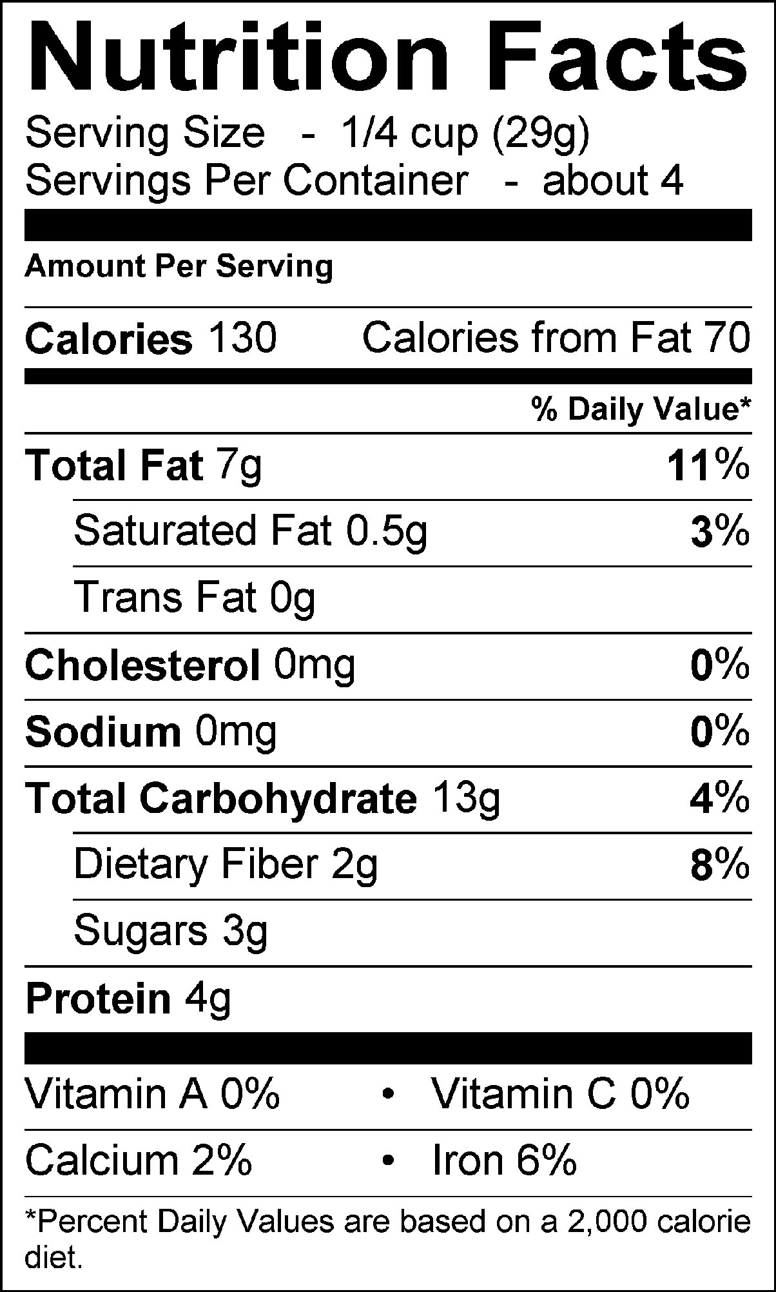

1. How many total calories are in this box of cereal?

**A** 130 calories **B** 134 calories **C** 520 calories **D** 560 calories

1. How many total grams of protein are in the entire box?

**A** 4 g **B** 8 g **C** 12 g **D**  16 g

1. Adreena ate two serving sizes of cereal. Which equation models the amount of cereal Adreena ate?

**A** cup + cup = cup **C** 2 x cup = cup

**B**  cup x cup = cup **D**  2 + cup = cup

**Use the picture below to complete problems 4 - 6.**

|  |  |  |
| --- | --- | --- |
|  |  |  |
|  |  |  |  |
|  |  |  |  |  |

1. The picture above represents tiles on Joe’s kitchen floor. Only 1/3 of the floor is represented in the picture. How many more tiles would be needed to show the whole floor?

**A** 12 tiles

**B** 24 tiles

**C** 36 tiles

**D** 48 tiles

1. Which expression tells how many tiles are needed for the whole floor?

**A** 12 + 12 + 12 + 12 **C** 3 x 

**B**  +  +  **D** 12 x 3

1. If one of the pieces shown in the shape above is equal to ¼ units, how many blocks should you color to equal 2 ½ units?

**A** blocks

**B** 4 blocks

**C** 8 blocks

**D** 10 blocks

**Choose the best answer for questions 7 - 10.**

1. The width of a rectangle is 6 ft. What is the perimeter of the rectangle if its area is 42 square feet?

**A** 26 feet

**B** 36 feet

**C** 42 feet

**D** 48 feet

1. Maria is having a party and wants to have 100 balloons. It takes 4 minutes to blow up and tie a balloon. If 5 people are blowing up balloons for the party, how long will it take to blow up and tie all of the balloons for the party?

**A** 1 hour

**B** 1 hour 20 minutes

**C** 4 hours

**D** 4 hours 20 minutes

1. Use the clues below to determine Luke’s house number.

The **first digit** is the number you multiply by 2 to get a product of 2.

The **second digit** is the first digit multiplied by 8.

The **third digit** is the difference between 6 and the 4th digit.

The **fourth digit** minus the first digit equals 5.

What is Luke’s house number?

**A** 1806

**B** 1825

**C** 1865

**D** 2865

1. Use the clues below to tell what the mystery number could be.

**The mystery number is between 40 and 80.**

**You say the number when you count by threes and fives.**

**It is an even number.**

What is the mystery number?

**A**  45 **B** 60 **C** 70 **D** 75

**Use the information below to answer questions 11 - 13.**

Georgia, Jordy and Nan placed points on the number line below. They did not identify the numbers so that they could use benchmark fractions to figure what each other’s numbers could be.

**G J N**

|  |  |
| --- | --- |
|  |  |
|  |  |

0   1

**Select all the letter choices that answer the questions below.**

1. Which two answer choices could **not** represent point J?

**A** ** B  C  D  E **

1. Which three answer choices could **not** be equivalent to point G?

**A**  0.70 **B** 0.5 **C**  0.10 **D** 1.0 **E** 0.25

1. Which two statements best describe point N?

**A** Point N could not be  because  is less than .

**B** Point N could be  because it is greater than .

**C** Point N could be equivalent to 0.8 because  is close to .

**D** Point N could not be  because is equivalent to 0.23 which is close to 0.

**E** Point N could be  because it is close to 1 whole.

**Choose the best answer for question 14.**

1. Which **three** comparisons are correct?

**A** 0.4 meter > 0.04 meter

**B** 0.04 meter > 0.3 meter

**C** 0.3 meter < 0.5 meter

**D** 0.5 meter > 0.65 meter

**E** 0.65 meter > 0.61 meter

**F** 0.65 meter < 0.04 meter

1. The number 234 is multiplied by 10. Which statement is true about the digit 2 in the product?

**A** The value of the digit 2 in the product is 20.

**B** The value of the digit 2 in the product is 200.

**C** The value of the digit 2 in the product is 2,000.

**D** The value of the digit 2 in the product is 20,000.

1. Kelly thinks the answer to #15 is D. Is she correct or incorrect? Explain your reasoning in the space below.