BIOLOGY

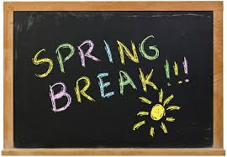
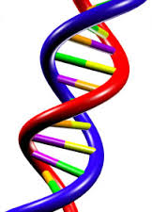
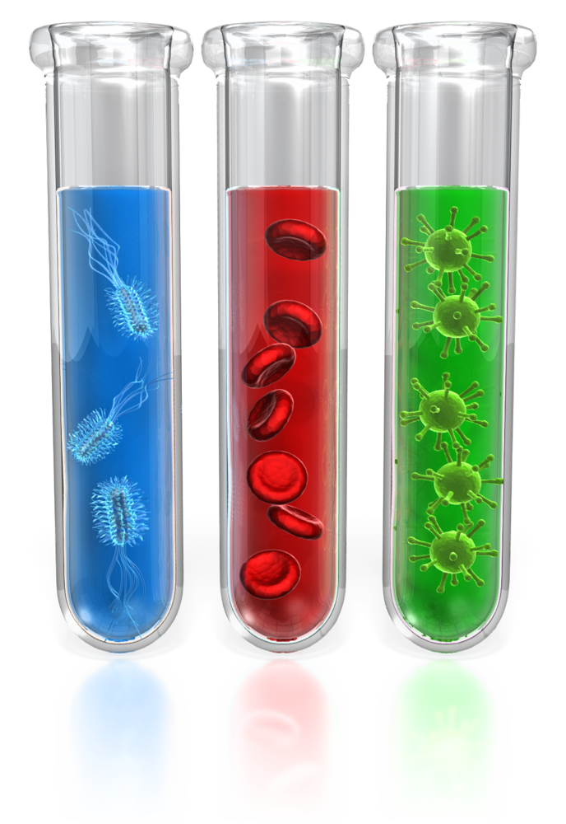

PRINCE GEORGE’S COUNTY PUBLIC SCHOOLS
Office of Academic Programs
Department of Curriculum and Instruction

Spring Break
Enrichment Packet

Read each question. Circle the letter of the correct answer.

1. A stem cell in an animal divides by mitosis. Which statement is true about the two daughter cells?

A. They each have identical functions.
B. They each have the same DNA sequences.
C. They are the same size and shape as their parent cell.
D. They each have half as many chromosomes as their parent cell.

2. Which hypothesis about cells was later found to be wrong by scientists?

A. The cell is the most basic unit of life.
B. All organisms are made of cells and cell products.
C. Cells are formed spontaneously by free-cell formation.
D. Plant cells and animal cells share structural similarities.

3. How did the invention of the light microscope lead to the development and refinement of cell theory over time?

A. Cells could now be seen in very low light so that studies of reproduction could take place at night.
B. Light microscopes allowed for the visualization of internal cell parts at magnifications over 1,000 times.
C. As microscopes became more powerful, scientists could see additional structures and functions within the cell.
D. Scientists kept what they saw through the lens of the light microscope to themselves to be sure they got all the credit for the discovery.
4. The model shows what happens to chromosomes during a certain part of the cell cycle.

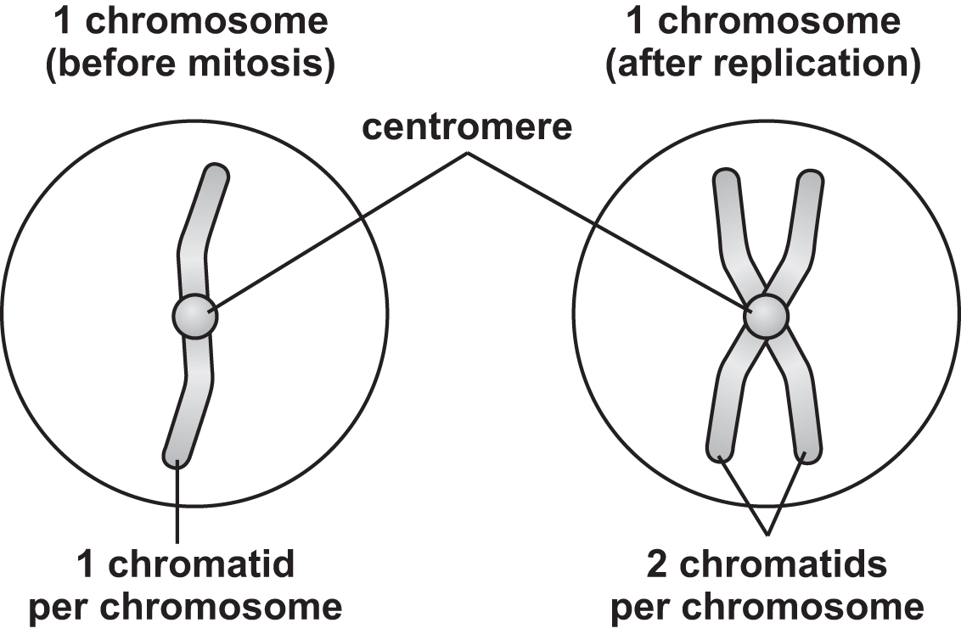

Which phase is being represented here?

A. Metaphase
B. Interphase
C. Telophase
D. Anaphase

5. A person cuts their finger. How does the process of mitosis help to repair the wound?

A. Mitosis forms a clot to prevent blood from flowing.
B. Mitosis allows air to enter the skin to encourage healing.
C. Mitosis prevents bacteria from entering the site of injury.
D. Mitosis forms new cells in the area where the old ones were damaged.

6. The model shows a cellular process.
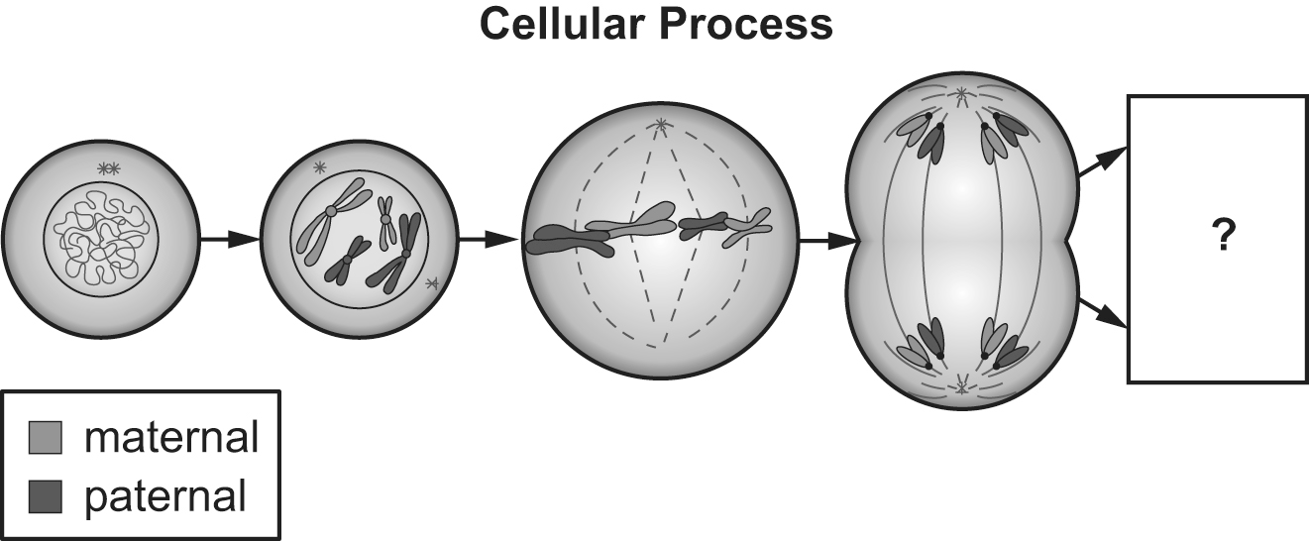

What will be the end result of the process shown in the model?

A. Two identical daughter cells will be produced.
B. Crossing over will result in new genetic material.
C. Chromatids will have just moved toward opposite poles.
D. One much larger cell will be produced through nuclear fusion.

7. A scientist is growing two cells in the same media. One cell has a diameter that is 4 times that of the other cell. If the smaller cell has a volume of 100 cubic micrometers, what is the volume of the larger cell? Write your answer on the line.

__________ cubic micrometers

8. A student created the following models to show the chromosomes during the phases of mitosis. Write the letters of the pictures in the box next to the correct mitosis phase.

anaphase  metaphase  telophase | A. 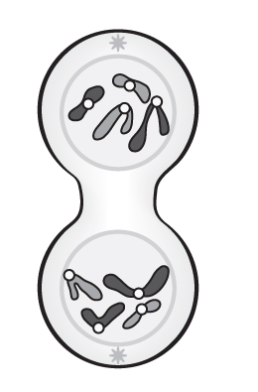 B. 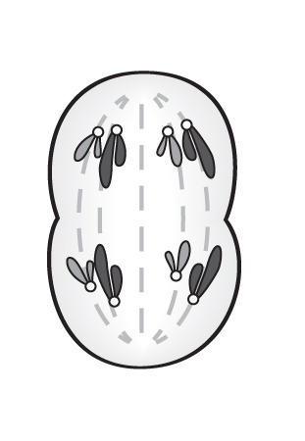 C. 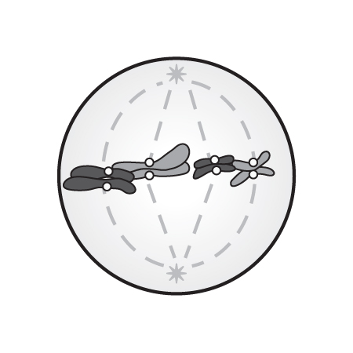

Read each question. Circle the letter of the correct answer.

9. DNA is the hereditary molecule that determines hair color in humans. However, the DNA molecule itself is colorless. How does DNA determine the hair color of individuals?

A. The sequence of DNA determines the structure of lipids, which produce phenotypes.
B. The sequence of DNA determines the structure of proteins, which produce phenotypes.
C. The sequence of DNA determines the structure of phosphates, which produce phenotypes.
D. The sequence of DNA determines the structure of carbohydrates, which produce phenotypes.

10. Franklin, Watson, and Crick’s model of DNA shows a double helical structure where two strands of DNA run antiparallel to each other. How does this structure cause the amount of purines to equal to the amount of pyrimidines as observed by Chargaff?

A. If adenine is on one strand, guanine must be on the other strand.
B. If adenine is on one strand, cytosine must be on the other strand.
C. If adenine is on one strand, thymine must be on the other strand.
D. If thymine is on one strand, cytosine must be on the other strand.
11. A strand of RNA has the sequence AUUGCGCGAA. What explanation can be made about how this strand came to be?

A. The RNA strand formed from the rearrangement of the bases in a DNA strand.
B. The RNA strand broke off from a DNA strand that had a much longer genetic code.
C. The RNA strand was transcribed from a DNA strand with the sequence TAACGCCTT.
D. The RNA strand was translated from a DNA strand that had the sequence UAACGCCUU.

12. What evidence would be needed to support an explanation about how RNA is formed from a DNA molecule during protein synthesis?

A. evidence that shows adenine from DNA being replaced by uracil in an RNA molecule
B. evidence that shows the translation of DNA into RNA during the last stages of the process
C. evidence that shows how the double-stranded DNA molecule splits apart into two RNA molecules
D. evidence that shows the original DNA strand and the resulting RNA strand after transcription has occurred

13. If a segment of DNA has the sequence ATCCGA, what would be the complementary mRNA sequence for that segment? Write the correct sequence on the line.
____________________________________

14. Which external factors can affect gene expression in an organism? Circle the letters of all the external factors that can affect gene expression.
A. predation  B. temperature  C. amount of light | D. drugs and chemicals  E. genetic makeup of organism

15. Occasionally during replication, the wrong nucleotide is added to the new strand of DNA. If the substitution is not fixed, it can have negative implications for the organism. Number the steps from 1 to 5 to show how DNA replication errors are handled.
DNA polymerase detects an error in replication.
DNA polymerase takes in a single strand of DNA and adds the matching nucleotides to make double-stranded DNA.
Errors have been limited and replication continues until the entire strand has been copied.
Replication is halted.
DNA polymerase removes the incorrect nucleotide and replaces it with the correct one.

16. The model below shows the structure of two molecules. Which statements about the two structures seen in the model are correct? Circle the letters of all the correct statements.
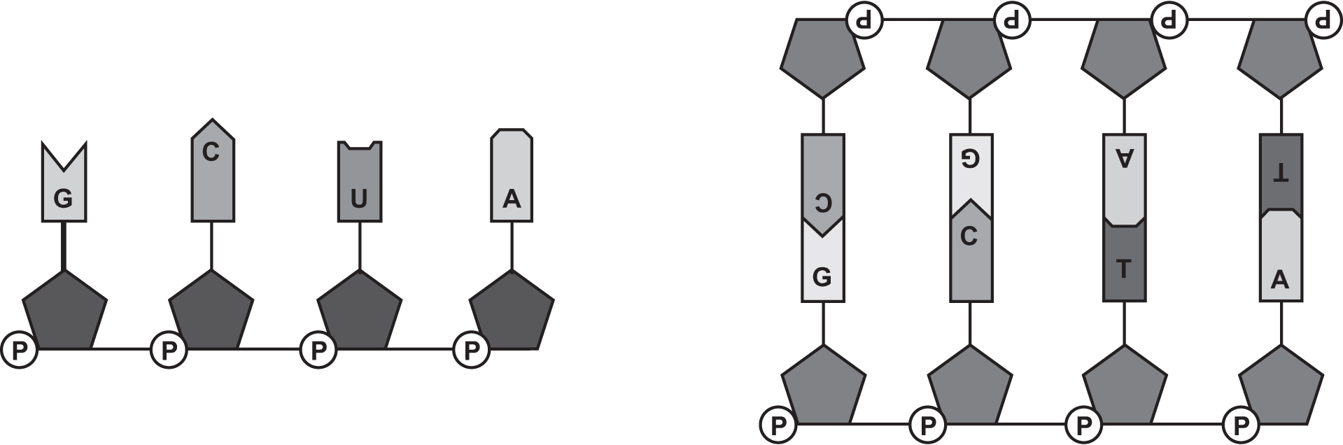
A. DNA has A, C, G, U, while RNA has A, C, G, T.
B. DNA is double stranded, while RNA is single stranded.
C. DNA uses deoxyribose as its sugar, while RNA has ribose as its sugar.
D. DNA has a 6-carbon sugar as its backbone, while RNA has a 5-carbon sugar.
E. DNA strands are held together by phosphate, while RNA molecules are bonded by uracil.
17. Luna is studying the different types of RNA that play a role in protein synthesis. Write the letter of each description in the correct box.
mRNA | rRNA | tRNA

A. forms subunits of ribosomes
B. carries amino acids to ribosomes
C. carries transcribed code for a protein

18. Write the letter of each conclusion in the box next to the scientific discovery that supports it. Some letters may be used more than once.
Oswald Avery observed that when DNA is destroyed, bacteria transformation did not occur. |  |  | A. DNA is shaped like a helix.  B. DNA is the hereditary material.  C. DNA bases pair according to rules.
Rosalind Franklin took x-ray photographs of DNA that showed an X surrounded by a circle.
Erwin Chargaff found that different species have similar ratios of purines to pyrimidines in their DNA.
Alfred Hershey and Martha Chase found that when bacteria are infected by bacteria, phosphorous from viral DNA remains in the bacteria.

19. Chris is studying the different ways in which a mutation can happen during translation. Write the letters of the terms in the blanks to correctly complete the sentences. Some letters will not be used.
A mutation that happens when a single nucleotide is replaced by a different one is a __________ mutation, also known as a substitution mutation. A mutation caused by the addition of a nucleotide into the DNA sequence is known as a(n) __________ mutation. This is a type of __________ mutation because it causes a change in the reading frame of the DNA.
A. deletion C. insertion
B. frameshift D. point

Read each question. Circle the letter of the correct answer.

20. Which is not a factor that could increase the rate of mutations in a cell?
A. exposure to a chemical carcinogen
B. infection with a virus, such as HPV
C. exposure of the cell to UV radiation
D. environmental pressure to adapt for survival

21. A scientist analyzes a karyotype of a skin cell of an animal. Which of these would best describe this karyotype?

A. The karyotype is haploid.
B. The karyotype has no autosomes.
C. The karyotype has matching sex chromosomes.
D. The karyotype has an even number of chromosomes.

22. Robert and his wife are ready to start a family, but they are concerned about having a child with an inherited disease. This disease is an autosomal recessive disorder that requires both parents to contribute a recessive allele in order for the child to express the disorder. If both Robert and his wife are heterozygous for this trait, what is the probability that one of their children will have the disease?

A. 25%
B. 50%
C. 75%
D. 100%

23. Which description supports the claim that mutations in gametes could cause an increase in genetic diversity in a population?

A. A deletion during meiosis results in a new version of an allele.
B. A drug creates a mutation in a liver cell. The mutated cell multiplies.
C. UV rays create thymine dimers that negatively affect a skin cell’s function.
D. A brain cell has a missense mutation that allows it to function more effectively.

24. Cisplatin is a drug that can be used for cancer patients. Scientists examined the effects of cisplatin treatment in mice by measuring the recombination index, which is a measure of how often recombination occurs between homologous chromosomes. Their results are shown in the graph.
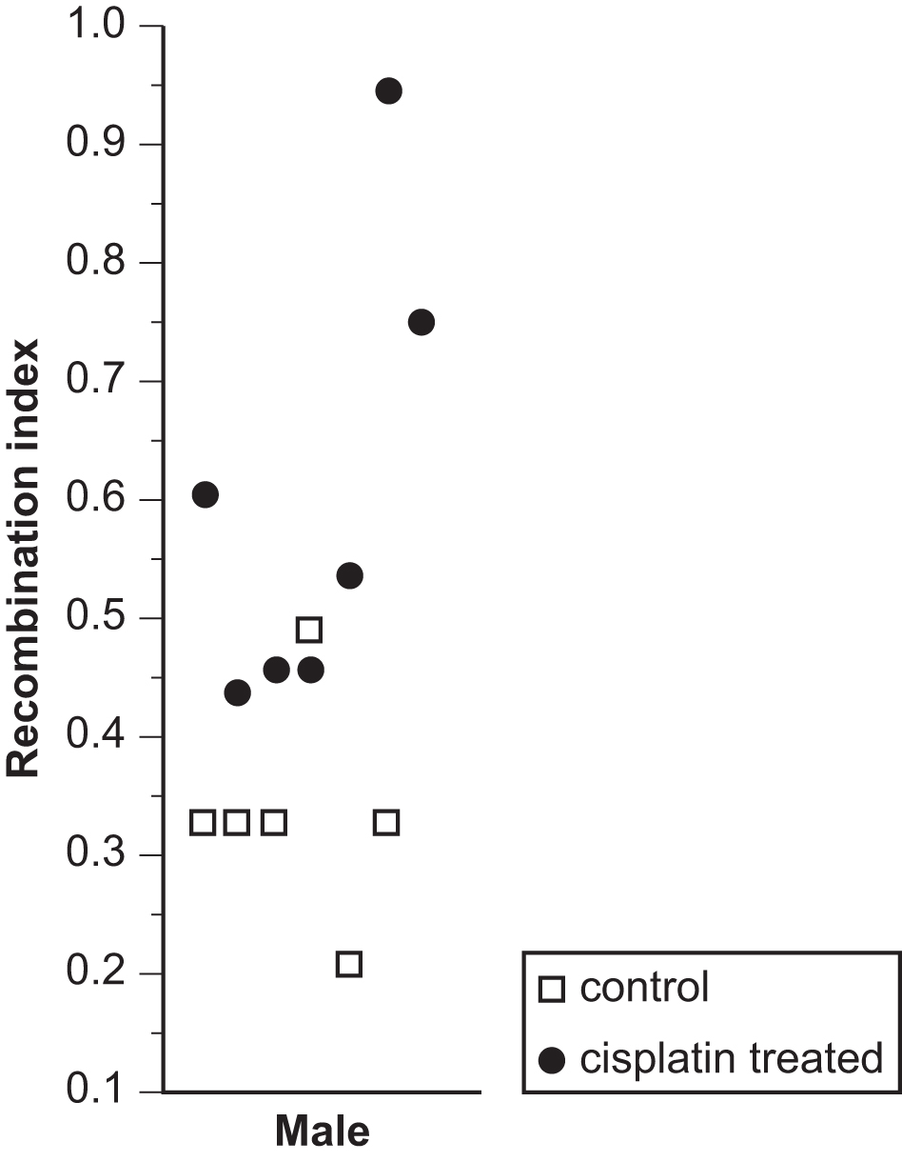
Which statement is best supported by the data?

A. Genetic diversity would be increased in the offspring of mice dosed with cisplatin.
B. Genetic diversity would be decreased in the offspring of mice dosed with cisplatin.
C. The number of diploid organisms would be increased in the offspring of mice dosed with cisplatin.
D. The number of diploid organisms would be decreased in the offspring of mice dosed with cisplatin.

25. The three main errors that result in chromosomal mutation are gene duplication, nondisjunction, and translocation. Write the letter of the type of error that likely caused each mutation next to the description of the mutation. Some letters may be used more than once.
A karyotype shows that an individual has three copies of chromosome 21.
Genetic testing shows a person has a section of chromosome 15 located on chromosome 2. |  |  | A. gene duplication  B. nondisjunction  C. translocation
Scientists inserting a genetic mutation into mice find one of the mice has two non-mutated copies of the gene as well as the mutated copy they inserted.
A plant is found to be tetraploid, meaning that instead of homologous pairs it contains homologous quadruplets for each chromosome number.

26. Meiosis is the process by which many organisms produce haploid genomes in preparation for sexual reproduction. A scientist proposes this model for meiosis in a triploid organism.
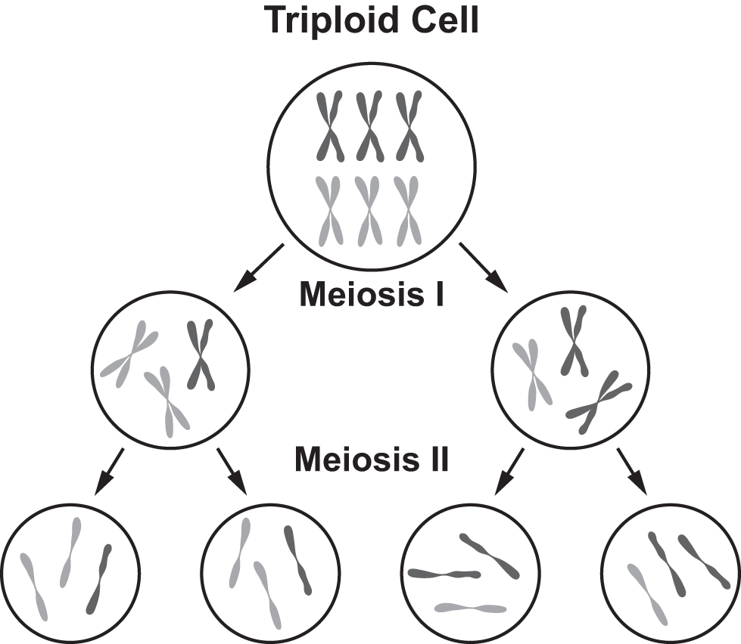
Identify one aspect of this model that is different from the meiosis of a diploid organism.

The scientist wants to test the accuracy of this model. Propose one question that the scientist can ask to test this model.

Directions: Use the passage to answer questions 27 and 28.

Raising Chickens
A family is raising chickens. They desire to increase certain desirable characteristics while eliminating the less-desirable traits. One of the traits that is important to this family is the type of comb that the male birds express. The comb is a fleshy projection on the top of the heads of male chickens. Four different comb types are possible: wild-combed, rose-combed, pea-combed, and walnut-combed, as shown in the image.

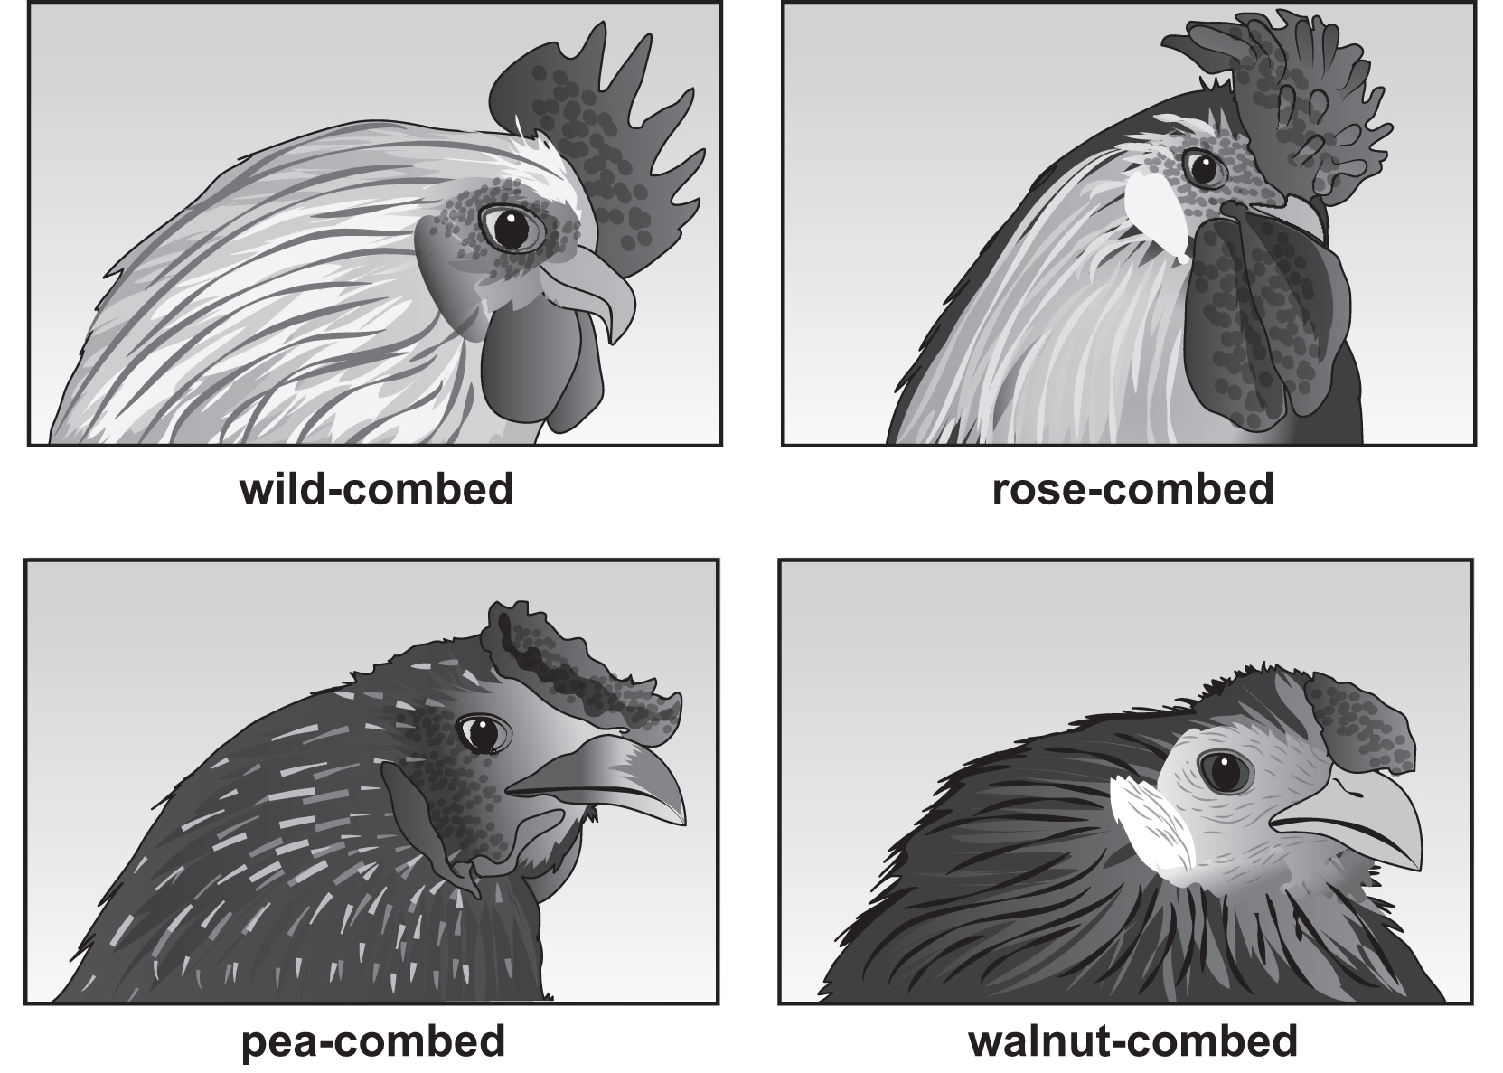

In order to inherit a wild comb, the male needs to be homozygous recessive for both traits (rrpp). If it inherits at least one dominant R, it will be rose-combed and if it receives at least one dominant P, it will be pea-combed. Finally, if the male chicken receives at least one R and one P, it will be walnut-combed.

27. If this family would like to breed a wild-combed chicken with a walnut-combed chicken, what is the probability that the result would be an offspring with wild combs? Circle the letter of the correct answer.
A. 0%
B. 25%
C. 50%
D. 100%

28. Feather color is a highly prized trait in chickens. One of the loci that controls feather color has two alleles, black (Bl) and blue (bl⁺). A chicken that has two black alleles (Bl/Bl) is black, and a chicken that has two blue alleles is blue (bl⁺/bl⁺). However, a chicken that inherits one of each trait (Bl/bl⁺) is an intermediate of the two. If two intermediate-colored chickens together produced 100 chicks, how many would you expect to be black? Circle the letter of the correct answer.
A. 25
B. 50
C. 75
D. 100
29. Yellow skin in chickens is a trait that is desirable. Yellow skin color in chickens is determined by a recessive allele (w), while the white allele (W) is dominant. The pedigree shown is a representative of the individuals in the Brown family’s flock with the squares representing the males and the circles representing the females.
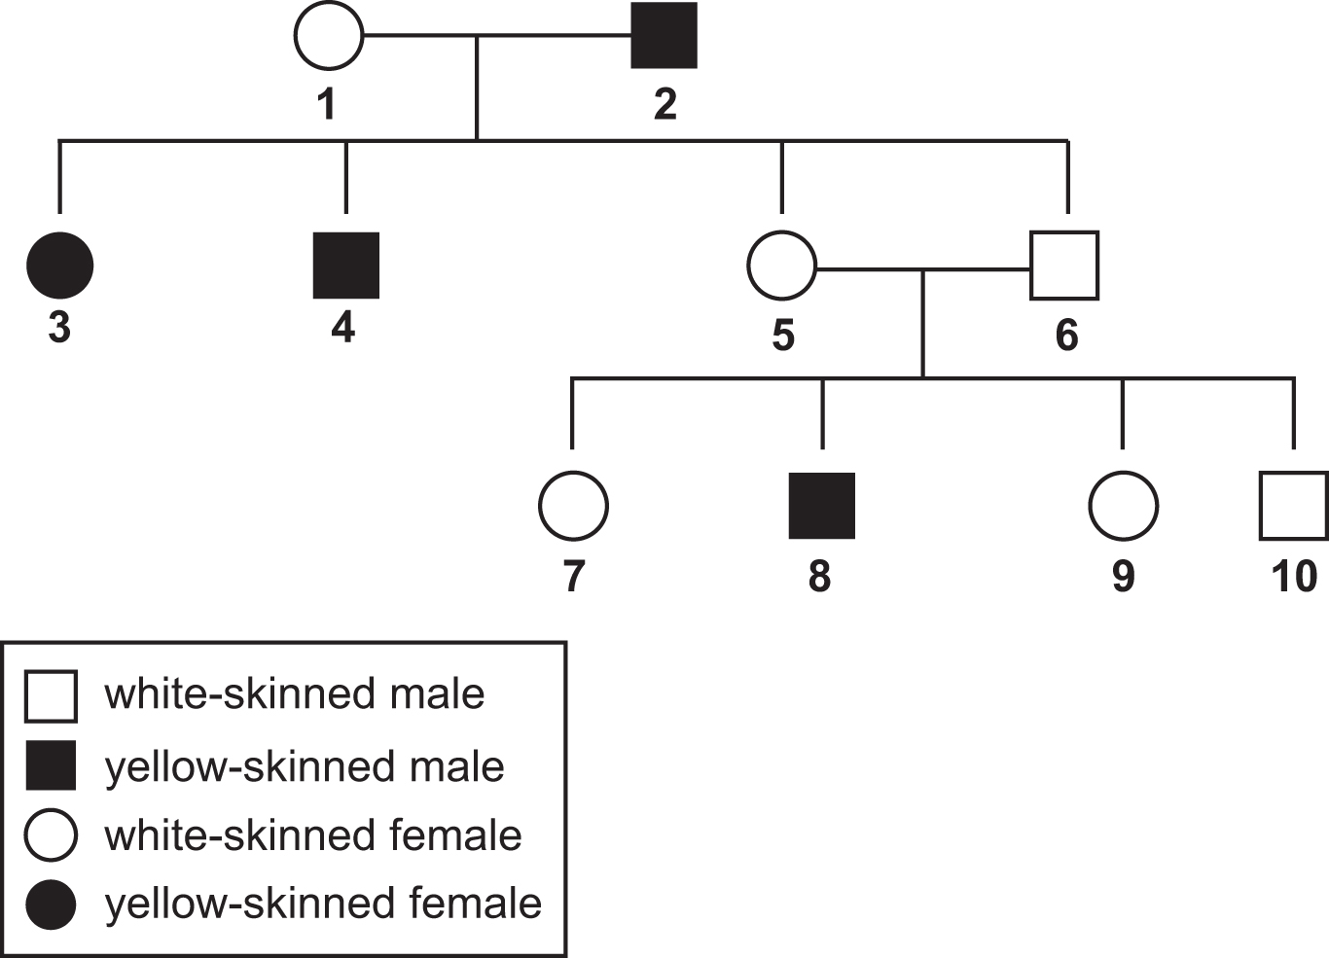

Write an X in the correct cell in the table to show the genotype for each individual listed. Write an X in the column labeled “WW or Ww” if a determination between these two genotypes cannot be made.
 | WW | Ww | ww | WW or Ww
A. individual 1
B. individual 5
C. individual 8
D. individual 9

30. One trait that the family wished to produce was barred feathers, which causes the feathers to look like they have a striped pattern. The allele for barred feathers is dominant and it is located on the sex chromosome, so the trait is considered to be sex linked. Chickens are a bit different from humans in that the male carries two of the same chromosomes to determine gender (ZZ), and the female carries one of each type of sex chromosome (ZW). Therefore, males carry two alleles for this trait and females carry only one. This family has a male chicken that is not barred Z^{b}Z^{b}) and a female that is barred (Z^{B}W).Write your answer on the lines.
Predict how many of the female and male chicks produced from this mating would be barred. Explain how you came to this conclusion.

If an environmental factor was discovered that caused more female chicks to be produced than male chicks, how would this change the percentage of barred chickens in the family’s flock?

Biology
Spring Break Packet Answer Key
Item Number | Answer | Standard
 | B. During mitosis two daughter cells are produced that are identical to each other. | NGSS.SCI.HS-LS1-4
 | C. Cells are made by other cells, not by spontaneous generation. | NGSS.SCI.HS-LS1-4
 | C. More powerful microscopes allowed for the visualization of internal cell structures and functions. | NGSS.SCI.HS-LS1-4
 | B. Chromosomes duplicate during this step, thus ending with two sister chromatids joined at the centromere. | NGSS.SCI.HS-LS1-4
 | D. Mitosis is the process that forms new cells at the site of injury. | NGSS.SCI.HS-LS1-4
 | A. Identical daughter cells are produced after the last step of the cellular process shown, which is mitosis. | NGSS.SCI.HS-LS1-4
 | 6,400 cubic micrometers. The larger cell would have a volume that is 4 cubed as great as the smaller cube, which means its volume would be 4 x 4 x 4 x 100 cubic micrometers. | NGSS.SCI.HS-LS1-4
 | A. This picture matches telophase because it shows the chromosomes reaching the two poles of the cell, and this is what occurs during telophase.  B. This picture matches anaphase because it shows the sister chromatids being separated, which is what occurs during anaphase.  C. This picture matches metaphase because it shows the sister chromatids lining up in the middle of the cell, which occurs during metaphase. | NGSS.SCI.HS-LS1-4
 | B. DNA codes for proteins, and those proteins produce phenotypes. | NGSS.SCI.HS-LS1-1
 | C. The double helix requires base pairing, and adenine pairs with thymine. | NGSS.SCI.HS-LS1-1
 | C. DNA gets transcribed into RNA and the thymine bases are replaced with uracil. | NGSS.SCI.HS-LS1-1
 | D. DNA is transcribed into RNA and would provide proof that RNA is formed from DNA. | NGSS.SCI.HS-LS1-1
 | The correct mRNA sequence would be UAGGCU. | NGSS.SCI.HS-LS1-1
 | B. This is correct because temperature can influence which proteins are produced.  C. This is correct because amount of light can influence which proteins are produced.  D. This is correct because drugs and chemicals can influence which proteins can be made. | NGSS.SCI.HS-LS1-1
 | First, DNA is matched to nucleotides. Errors are then detected and replication stops. The incorrect nucleotide is removed and replaced with the correct nucleotide. This process continues until the entire strand of DNA has been copied. | NGSS.SCI.HS-LS1-1
 | B. This is correct because DNA is a double helix, while RNA is single stranded.  C. This is correct because the sugar in DNA is deoxyribose, and the sugar in RNA is ribose. | NGSS.SCI.HS-LS1-1
 | A. This description belongs in the rRNA column, because rRNA makes up ribosomes.  B. This description belongs in the tRNA column, because tRNA transfers amino acids to ribosomes.  C. This description belongs in the mRNA column, because mRNA makes up the messages that code for proteins. | NGSS.SCI.HS-LS1-1
 | A. DNA is shaped like a helix matches Rosalind Franklin took x-ray photographs of DNA that showed an X surrounded by a circle because this discovery showed the most likely shape of DNA is helical.  B. DNA is the hereditary material matches Oswald Avery observed that when DNA is destroyed, bacteria transformation did not occur and Alfred Hershey and Martha Chase found that when bacteria are infected by bacteria, phosphorous from viral DNA remains in the bacteria because both suggested that the material in the cell that is responsible for expressed traits is DNA.  C. DNA bases pair according to rules matches Erwin Chargaff found that different species have similar ratios of purines to pyrimidines in their DNA because this discovery helped support Chargaff’s rules of base pairing. | NGSS.SCI.HS-LS1-1
 | A. Deletion does not belong in any blank because it does not correctly complete any of the sentences.  B. Frameshift belongs in the third blank because a frameshift mutation happens when there is a change in the reading frame.  C. Insertion belongs in the second blank because insertion mutations happen when a nucleotide is inserted into the DNA sequence.  D. Point belongs in the first blank because a point mutation is a mutation in which a single nucleotide is replaced by a different one. | NGSS.SCI.HS-LS1-1
 | D. This is correct because the need to adapt cannot cause genetic mutation. Adaptations are often derived from genetic mutations, but individual organisms cannot choose to change their genes to adapt. | NGSS.SCI.HS-LS3-2
 | D. This is correct because somatic cells, such as animal skin cells, are diploid. | NGSS.SCI.HS-LS3-1
 | A. This is correct because if both parents are heterozygous, there is a 25% chance that they will both pass on the recessive allele to their child. | NGSS.SCI.HS-LS3-3
 | A. This is correct because meiosis occurs in germ cells, which will pass on to offspring and thus the population. | NGSS.SCI.HS-LS3-2
 | A. This is correct because the cisplatin increases recombination, which increases genetic diversity. | NGSS.SCI.HS-LS3-1
 | A. Gene duplication matches the third description because gene duplication occurs when just a section of a homologous chromosome does not separate during meiosis. It can be either harmful or beneficial.  B. Nondisjunction matches the first and fourth descriptions because each is an example of failure of chromosomes to separate during meiosis. When homologous chromosomes do not separate, it is called nondisjunction.  C. Translocation matches the second description because this is an example of when genes are swapped on nonhomologous chromosomes (such as chromosomes 15 and 2). | NGSS.SCI.HS-LS3-2
26. Use the rubric below to evaluate question 26.

Evidence of Mastery of Disciplinary Core Ideas | Part 1:  - This model produces four gametes that have different numbers of each chromosome. | NGSS.SCI.HS-LS3-1
Evidence of Mastery of Science and Engineering Practices | Part 2:  - To test the model, the scientist can ask whether triploid cells produce gametes with different numbers of each chromosome. | NGSS.SCI.HS-LS3-1
Item Number | Answer | Standard
27. | A. This is correct because the wild-combed parent will contribute only recessive alleles while the walnut-combed parent will contribute only dominant alleles; thus, the resulting chicks will all be RrPp (walnut-combed). Since only walnut-combed chickens are produced, the probability of a wild-combed is 0%. | NGSS.SCI.HS-LS3-1
28. | A. This is correct because both parents are (Bl/bl⁺); thus 25% of the offspring would be (Bl/Bl), so 25 chicks. | NGSS.SCI.HS-LS3-3
29. | A. The correct selection for Individual 1 is Ww, since a cross between individuals 1 and 2 produces some offspring with yellow skin.  B. The correct selection for Individual 5 is Ww since the individual has white skin, but a cross with individual 6 produces a yellow-skinned chick.  C. The correct selection for Individual 8 is ww since this chick has yellow skin, which is recessive.  D. The correct selection for Individual 9 is WW or ww. Since both parents are white-skinned, there is a chance that individual 9 inherited a dominant allele from both parents. However, it could also have inherited a dominant allele from one parent and a recessive allele from the other. | NGSS.SCI.HS-LS3-3

30. Use the rubric below to evaluate question 30.
Evidence of Mastery of Disciplinary Core Ideas | Part 1:  - Because the male parent is nonbarred (Z^{b}Z^{b}) and the female parent is barred (Z^{B}W), only the male offspring would be barred. All of the female chicks would be nonbarred. This is because the male parent gives the Z^{b} allele to both the male and female offspring while the female parent gives the Z^{B} allele to only the male offspring.  Part 2:  - If the environment causes more females to be produced than males, the percentage of barred chicks in the flock would decline. This is because only the males from this cross can be barred, and if there are fewer of these produced, then more nonbarred chicks would be produced. | NGSS.SCI.HS-LS3-3

