Math 7
Spring Student
Enrichment Packet

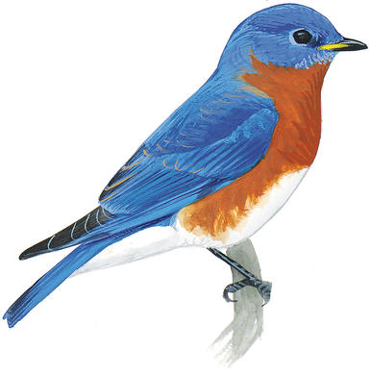
ANSWER KEY

PRINCE GEORGE’S COUNTY PUBLIC SCHOOLS
Office of Academic Programs
Department of Curriculum and Instruction

™

Math 7 Spring Enrichment Packet

Answer Key

Problem | Answer
1 | A, B, D
2 | 82
3 | Rectangular has the greater area by 1.8 square feet
4 | 20
5 | A
6 | If she earns $450 for 40 hours of work, then Brenda earns $11.25 per hour.  If she works 55 hours, she will still earn $450 for the first 40 hours. Then she will earn $11.25 x 1.5 = $16.88 for the next 15 hours of work. So 15 x $16.88 = $253.20, and $253.20 + $450 = $703.20.
7 | 9
8 | 61.5
9 | B, E
10 | C
11 | To get 75 seeds:  - At Go-Green: To buy at least 75 seeds, you need to buy 7 packets. 7 x 12 = 84, so there will be 9 seeds left over after spending $3.80 x 7 = $26.60.  - At Giant Seeds: To buy at least 75 seeds, you need to buy 5 packets. 5 x 18 = 90, so there will be 15 seeds left over after spending $4.40 x 5 = $22.00.  - At Seeds-R-Us: To buy at least 75 seeds, you need to buy 8 packets. 8 x 10 = 80, so there will be 5 seeds left over after spending $2.50 x 8 = $20.00.  So, the students should buy their seeds at Seeds-R-Us because they will spend the least and have the fewest seeds left over.
12. Part A | 34.2 miles
Part B | 8.27 miles per hour
13. | 5.8 megabytes
14. | D, E
15. Part A | C = 3.5v
Part B | 3.5

