Accelerated 1
Spring Student Enrichment Packet

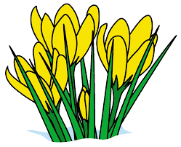
ANSWER KEY

PRINCE GEORGE’S COUNTY PUBLIC SCHOOLS
Office of Academic Programs
Department of Curriculum and Instruction

™

Accelerated 1 Spring Student Enrichment Packet

Answer Key
Problem | Answer
1 | 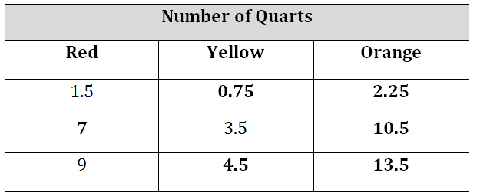
2 | 123
3 | A
4 Part A | $1.50
Part B | I know that each page costs $1.50, so 36 ÷ 1.5 = 24. So, a $36 photo book would have 24 pages
Part C | 1.5 x 0.4 = 0.6, and 0.6 + 1.5 = 2.10. So, each page of a large photo book costs $2.10.  If a large photo book has 30 pages, then 30 x $2.10 = $63 for the large photo book.
5 Part A | 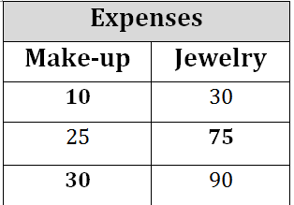
Part B | j = 3m or m = $\frac{1}{3}$j
Part C | Plotted points and graph line should show the correct relationship between makeup and jewelry expenses (that jewelry expenses are three times those of makeup).
Part D | The two points should have second coordinates that are three times the first.
6 | D
7 | C
8 | A
9 | C
10 | A, B, D
11 | C
12. | North Carolina, Syracuse, Kentucky, Arizona
13. | $2(\frac{3}{4}+\frac{5}{8}y-2x)$
14. | B
15. | A

