Algebra I Common Core
SPRING STUDENT
ENRICHMENT PACKET



™

Prince George’s County Public Schools
Office of Academic Programs
Department of Curriculum and Instruction

NOTE TO STUDENT

This Spring Student Enrichment Packet has been compiled to complement high school mathematics classroom instruction aligned to Maryland College and Career Ready Standards (MCCRS). It is intended to be used for review and practice of previously taught and new concepts.

We strongly encourage you to work diligently to complete the activities in this packet. You may experience some difficulty with some problems in this packet, but we encourage you to explore and attempt to find a solution to the best of your ability.



- Graph $f(x)=5x−\text{45}$.



- Identify intercepts.

Anthony threw a ball from the top of a 10-story building that was 165 feet tall. The equation $g(\text{165}−h)=\frac{1}{2}v^{2}$ can be used to find the maximum height the ball can attain after being thrown from the top of the building. In this equation g represents the acceleration due to gravity (32 feet per second squared), h is the maximum height attained by the ball, and v is the speed of the ball.

Rewrite the equation to highlight the maximum height attained by the ball, h.

Solve $−2p^{2}=\text{16}p+\text{24}$. Select all that apply.

- -6
- -2
- 2
- 3
- 4
- 6

The graph of f(x) is shown below.
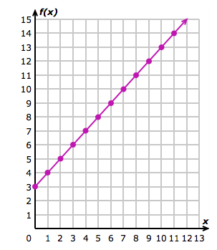

- Using the graph above, complete the table.

x | f(x)
2

4

5

11

- Write the linear function.

Which is a graph of the solution set of the inequality $\text{24}≥\frac{1}{2}(6x−8y)$? Select the correct answer.

A. | 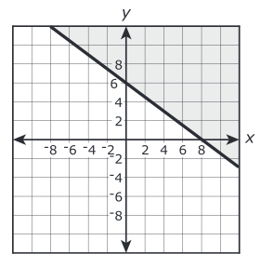 | B. | 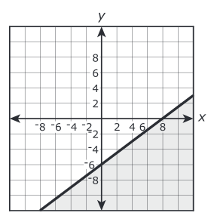
C. | 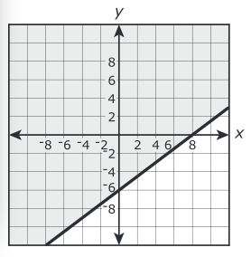 | D. | 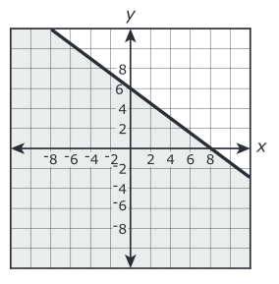

The figure shows the graphs of the functions $y=f(x)$ and $y=g(x)$. The four indicated points all have integer coordinates.
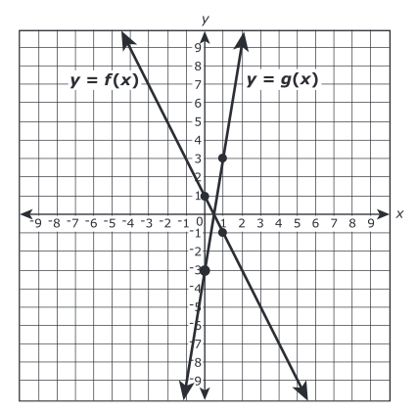

If $g(x)=k⋅f(x)$, what is the value of k?
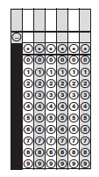

Consider the graph of $f(x)=x$ is shifted up 8 units, what would be the equation of the new graph? Select the correct answer.

- $$f(x)=8x$$
- $$f(x)=x−8$$
- $$f(x)=x+8$$
- $$f(x)=8−x$$

The dot plots shown below represent the daily high temperatures during the month of July for two different cities.

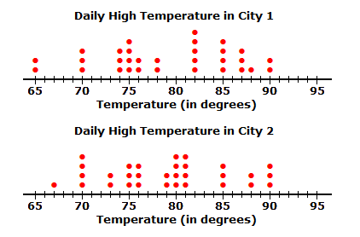

- For which city was the mean of the daily high temperature greater? Select the correct answer.

- City 1
- City 2
- Both means are equal

- For which city was the median of the daily high temperature greater? Select the correct answer.

- City 1
- City 2
- Both medians are equal

- For which city was the range of the daily high temperature greater? Select the correct answer.

- City 1
- City 2
- Both ranges are equal

A social networking website researched the ages of its male and female users. The findings were recorded in the the box plots below.

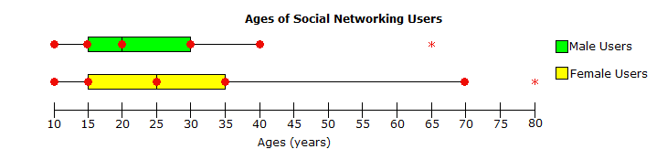

Which of the following statements are true regarding the box plots. Select all that apply.

- The age range of female users is greater than the age range of male users.

- The percentage of female users that are ages 10 – 15 is greater than the percentage of male users that are ages 10 – 15.

- The median age of female users is greater than the median age of male users.

- There is a 30-year age difference between the oldest female user and the oldest male user.

Gerry expands her square garden by 35 inches along its width. The area of the new garden can be found with the function below where x is the length in inches.

G = x² + 35x

Which statement best describes the term (35x)? Select the correct answer.

- the area added to the garden
- the area of the garden after the expansion
- the width of the garden
- the area of the garden before the expansion

Select the region that represents the solution to the following system of inequalities?

$$\begin{aligned}\left\{4x−2y≤0 | \right\}\end{aligned}\left\{\right\}$$

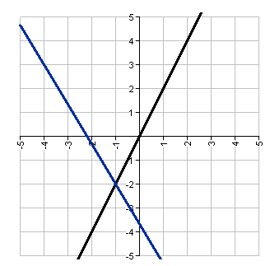
B
D
A
C

Solve $2x^{2}+\text{12}x=\text{66}$. Write the correct answer in each box.

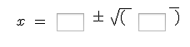

Simplify the polynomial expression $(5x−7)(9x^{2}−4x−8)$. Write the correct answer in each box.



Currently, there are 153 bald eagles in Forest National Park. Bald eagles are an endangered speicies, and the population of bald eagles is decreasing by 8% every year.

Which of the following functions represents the number of bald eagles in Forest Natioanl Park in t years? Select the correct answer.

A. $B(t)=\text{153}(−0\text{.}\text{92})^{t}$
B. $B(t)=\text{153}(1\text{.}\text{08})^{t}$
C. $B(t)=\text{153}(0\text{.}\text{92})^{t}$
D. $B(t)=\text{140}\text{.}\text{76}t$

The table represents the population, $P(x)$, of a community x years from 2000.

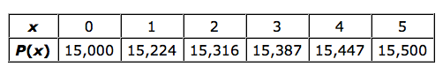

What does the y-intercept reprsent? Select the correct answer.

- the rate at which the population of the community is growing
- the number of years it takes for the population to reach zero
- the population of the community in 2005
- the population of the community in 2000

Turner Fuel Station tracked the percent increase in the the price of a gallon of regular unleaded gasoline for a week. The graph below shows the percent increase throughout the week.

Based on the graph, what is happening to gas prices on the interval (2, 6)?

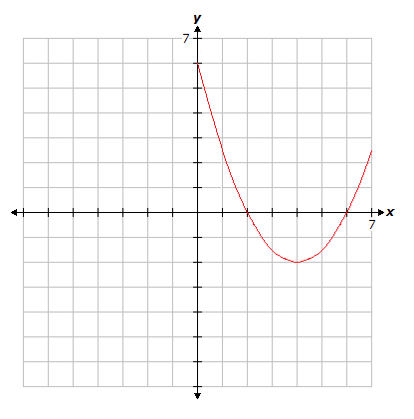
- gas prices have dropped below cost indicating a loss on every sale
- gas prices are decreasing over the entire interval
- gas prices are set below the national average
- gas prices are decreasing on the interval (2, 4) and increasing on the interval (4, 6)

A cartoonist uses the function $N(d)=\text{30}d−\text{420}$ to calcuate the net profit($) he earns from selling his drawings. In the function, d represents the number of drawings he sells.

What is the domain of $N(d)$? Select the correct answer.

- all non-negative real numbers
- all integers greater than or equal to 14
- all integers
- all non-negative integers

A train leaves a station with a shipment and is headed for another station to drop the shipment. The table represents the distance, in miles, the train has traveled after x hours.
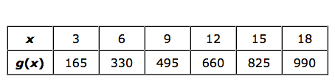

What is the average rate of change over the interval [9, 18]? Select the correct answer.

- 27.5 miles per hour
- 110 miles per hour
- 55 miles per hour
- 165 miles per hour

The graph below represents the value of an investment account x years from the date of the initial investment.
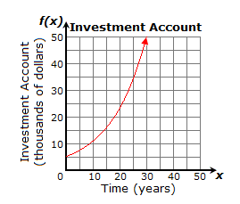

Estimate the rate of change over the interval [15, 25]. Select the correct answer.

- $2,600 per year
- $1,000 per year
- $1,500 per year
- $1,800 per year

The graph of f(x) is shown below.

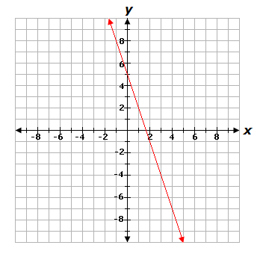

If $g(x)=4x+5$, which statement is true? Select the correct answer.

- The y-intercept of g(x) is less than the y-intercept of f(x).
- The rate of change of g(x) is greater than the rate of change of f(x).
- The y-intercept of g(x) is greater than the y-intercept of f(x).
- The rate of change of g(x) is less than the rate of change of f(x).

Which of the following shows a function? Select all that apply.

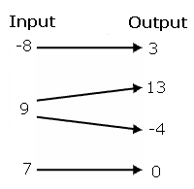
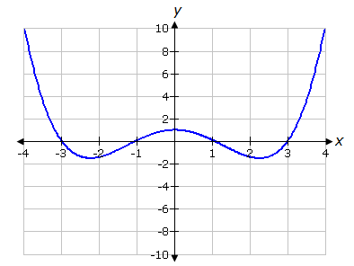
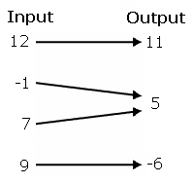
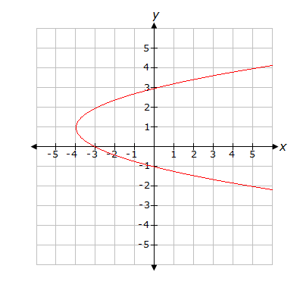
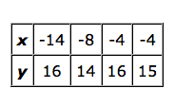
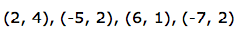

Following market trends, Water Core started making 10” tablet computers. They have fixed costs of $54,000 per month and variable costs of $147.20 per tablet made. The company sells the tablet for $209.00 each. The company’s profit function for the tablets is given by $p(x)=\text{61}\text{.}8x−\text{54},\text{000},$ where x is the number of tablets sold. After the debut, the company sold 2,160 tablets during the first month.

How much did Water Core make from their tablet division for the first month? Select the correct answer.

- $139.668.00
- $85,668.00
- $472,340.00
- $79,488.00

Graph the equation $5y−3x=−\text{15}$.

Carl knows the required height of the volume of a cone-shaped vase he’s designing.

Which formula can he use to determine the radius of the vase. Select the correct answer.

- $$r=\sqrt{\frac{V}{3πh}}$$
- $$r=\sqrt{\frac{V}{πh}}$$
- $$r=\frac{\sqrt{3V}}{πh}$$
- $$r=±\sqrt{\frac{V}{πh}}$$

A ball was thrown upward into the air. The height, in feet, of the ball above the ground t seconds after being thrown can be detemined by the expression $−\text{16}t^{2}+\text{40}t+3$.

What is the meaning of the 3 in the expression? Select the correct answer.

- The ball takes 3 seconds to reach its maximum height.
- The ball takes 3 seconds to reach the ground.
- The ball was thrown from a height of 3 feet.
- The ball reaches a maximum of 3 feet.

